Notice of Intent to Certify Sole Source

To: Interested Parties

From: Jennifer Douglas
Administrative Director, Category Management and Procurement

Date: February 14, 2024

Re: Sole Source Certification Number SS5847 for All reagents and kits related to the Chromium Controller

Contact Email Address: solesource@umc.edu

Sole Source Certification Award Details

Regarding UMMC Sole Source Certification Number SS5847 for all reagents and kits related to the Chromium Controller, please be advised that UMMC intends to award the purchase to 10X Genomics Inc. as the sole source provider.

UMMC issues this notice in accordance with Mississippi state law, policy, and procedures for sole source procurements.

Sole Source Criteria

- Where the compatibility of equipment, accessories, or replacement parts is the paramount consideration (and manufacturer is the sole supplier).
- Where a sole supplier’s item is needed for trial use or testing.
- Where a sole supplier’s item is to be required when no other item will service the needs of UMMC.

Schedule

Task | Date
First Advertisement Date | February 20, 2024
Second Advertisement Date | February 27, 2024
Response Deadline from Objectors | March 6, 2024 at 3:00 p.m. Central Time
Notice of Award/No Award Posted | Not before March 13, 2024

- Describe the commodity that the agency is seeking to procure:

The University of Mississippi Medical Center (UMMC) seeks to procure all reagents and kits related to the 10X Chromium Instrument which was purchased in 2019. These reagents and kits will be used for cell nuclei isolation and to perform analysis on the 10X instrument.

- An explanation of why the commodity is the only one that can meet the needs of UMMC.

UMMC Department of Pharmacology/Toxicology purchased the 10X Genomics Chromium Controller for research studies. These kits and reagents are the only compatible kits and reagents that can be used with this instrument.

- Explain why the source is the only person or entity that can provide the required commodity:

10X Genomics is the sole manufacturer of the Chromium Controller and reagents and kits required for its use. There are no other manufacturers that have access to this type of technology.

- Explain why the amount to be expended for the commodity is reasonable:

The estimated annual amount to be expended for the purchase of the reagents and kits for the Chromium controller is $300,000.00. This amount is within the expected price range for these products.

- Describe the efforts that the agency went through to obtain the best possible price for the commodity:

Pricing is compared against available market intelligence and identified discounts are pursued where applicable.

Submission Instructions and Format of Response from Objecting Parties

Interested parties who have reason to believe that the reagents and kits for the Chromium controller, (hereafter, “Products”) should not be certified as a sole source should provide information in the Vendor Form for the State to use in determining whether or not to proceed with awarding the sole source to 10X Genomics Inc. The Vendor Form may be found at http://www.dfa.state.ms.us/Purchasing/documents/ObjectiontoSoleSourceDetermination.pdf.

Objections must include the certification in Attachment B.

Comments will be accepted at any time prior to March 6, 2024, at 3:00 p.m. (Central Time) to solesource@umc.edu. Responses may be delivered via email to solesource@umc.edu. UMMC WILL NOT BE RESPONSIBLE FOR DELAYS IN THE DELIVERY OF RESPONSES. It is solely the responsibility of the Interested Parties that responses reach UMMC on time. Responses received after the deadline and responses that lack all required information will be rejected. UMMC reserves the right to inspect Interested Party’s commodity for comparison purposes.

If you have any questions concerning the information above or if we can be of further assistance, please contact solesource@umc.edu.

Attachment A: Vendor Correspondence
Attachment B: Objection Certification

Attachment A

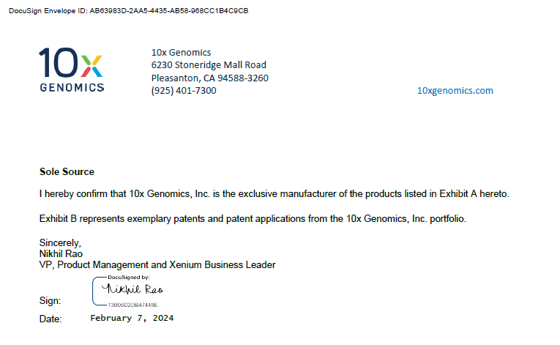

Attachment B

SUBMITTED IN RESPONSE TO
Sole Source Certification No. SS5847
Accepted until March 6, 2024 at 3:00 p.m.

I certify that the information contained in this objection is true and accurate to the best of my knowledge. I understand that UMMC will investigate all statements made in this objection and that any false or misleading information provided may result in adverse action.

__________________________________
Objector Name
Objector’s title

__________________________________
Date

