Notice of Intent to Certify Sole Source

To: Interested Parties

From: Jennifer Douglas
Administrative Director, Category Management and Procurement

Date: February 28, 2024

Re: Sole Source Certification Number SS5853 for Rat Behavioral Testing Equipment and Accessories

Contact Email Address: solesource@umc.edu

Sole Source Certification Award Details

Regarding UMMC Sole Source Certification Number SS5853 for Rat Behavioral Testing Equipment and Accessories, please be advised that UMMC intends to award the purchase to Med Associates Inc. as the sole source provider.

UMMC issues this notice in accordance with Mississippi state law, policy, and procedures for sole source procurements.

Sole Source Criteria

- Where the compatibility of equipment, accessories, or replacement parts is the paramount consideration (and manufacturer is the sole supplier).
- Where a sole supplier’s item is needed for trial use or testing.
- Where a sole supplier’s item is to be required when no other item will service the needs of UMMC.

Schedule

Task | Date
First Advertisement Date | March 11, 2024
Second Advertisement Date | March 18, 2024
Response Deadline from Objectors | March 27, 2024 at 3:00 p.m. Central Time
Notice of Award/No Award Posted | Not before April 3, 2024

- A description of the commodity that UMMC is seeking to procure.

UMMC and the Department of Psychiatry & Human Behavior are seeking to procure operant test chambers for rats. The chambers can be used to condition rats to respond for food/drug/alcohol as a reinforcer. When a rat presses a lever, a signal is sent to an interface and then to a computer to process the information. The computer in turn signals a pump to deliver an exact amount of food or drug (or alcohol) to the rat. The rats’ self-administration behavior is a translational model of human food/drug/alcohol taking. This preclinical procedure requires sophisticated hardware and software to ensure accurate and timely delivery of food/drug/alcohol that is dependent on the rat’s behavior.

- An explanation of why the commodity is the only one that can meet the needs of UMMC.

UMMC Department of Research is seeking to expand the current inventory of In Vivo test chamber for ongoing research. UMMC owns the associated software needed to operate the equipment as the current fleet is already comprised of Med Associates Inc. In Vivo test chambers.

- An explanation of why the source is the only person or entity that can provide the required commodity.

A sole-source justification for the manufacturer is included with this request (Attachment A). Briefly, the letter states that Med Associates Inc. is the sole proprietor and provider of this equipment. Therefore, it cannot be obtained from another source.

- An explanation of why the amount to be expended for commodity is reasonable.

The estimated annual amount to be expended for the purchase of the Rat Behavioral Testing Equipment and Accessories is $70,000.00. This amount is within the expected price range for these products.

- List the efforts that UMMC went through to obtain the best possible price for the commodity.

Pricing is compared against available market intelligence and identified discounts are pursued where applicable.

Submission Instructions and Format of Response from Objecting Parties

Interested parties who have reason to believe that the reagents and kits for the Chromium controller, (hereafter, “Products”) should not be certified as a sole source should provide information in the Vendor Form for the State to use in determining whether or not to proceed with awarding the sole source to Med Associates Inc. The Vendor Form may be found at http://www.dfa.state.ms.us/Purchasing/documents/ObjectiontoSoleSourceDetermination.pdf.

Objections must include the certification in Attachment B.

Comments will be accepted at any time prior to March 27, 2024, at 3:00 p.m. (Central Time) to solesource@umc.edu. Responses may be delivered via email to solesource@umc.edu. UMMC WILL NOT BE RESPONSIBLE FOR DELAYS IN THE DELIVERY OF RESPONSES. It is solely the responsibility of the Interested Parties that responses reach UMMC on time. Responses received after the deadline and responses that lack all required information will be rejected. UMMC reserves the right to inspect Interested Party’s commodity for comparison purposes.

If you have any questions concerning the information above or if we can be of further assistance, please contact solesource@umc.edu.

Attachment A: Vendor Correspondence
Attachment B: Objection Certification

Attachment A

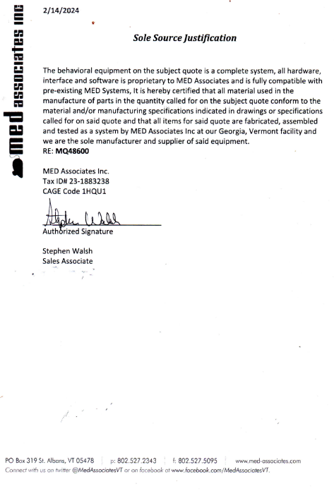

Attachment B

SUBMITTED IN RESPONSE TO
Sole Source Certification No. SS5853
Accepted until March 27, 2024 at 3:00 p.m.

I certify that the information contained in this objection is true and accurate to the best of my knowledge. I understand that UMMC will investigate all statements made in this objection and that any false or misleading information provided may result in adverse action.

__________________________________
Objector Name
Objector’s title

__________________________________
Date

