Notice of Intent to Certify Sole Source

To: Interested Parties

From: Jennifer Douglas
Administrative Director, Category Management and Procurement

Date: March 14, 2024

Re: Sole Source Certification Number SS5856 for Rack Washer Accessories

Contact Email Address: solesource@umc.edu

Sole Source Certification Award Details

Regarding UMMC Sole Source Certification Number SS5856 for Rack Washer Accessories, please be advised that UMMC intends to award the purchase to Better Built. as the sole source provider.

UMMC issues this notice in accordance with Mississippi state law, policy, and procedures for sole source procurements.

Sole Source Criteria

- Where the compatibility of equipment, accessories, or replacement parts is the paramount consideration (and manufacturer is the sole supplier).
- Where a sole supplier’s item is needed for trial use or testing.
- Where a sole supplier’s item is to be required when no other item will service the needs of UMMC.

Schedule

Task | Date
First Advertisement Date | March 25, 2024
Second Advertisement Date | April 1, 2024
Response Deadline from Objectors | April 10, 2024 at 3:00 p.m. Central Time
Notice of Award/No Award Posted | Not before April 17, 2024

- A description of the commodity that UMMC is seeking to procure.
A high capacity cage washing system utilizing two double sided racks and a central spray manifold. The unit is capable of processing up to 200 mouse cages or 60 rat cages/cycle.

- An explanation of why the commodity is the only one that can meet the needs of UMMC.
Current available wash racks do not provide the ability to process caging in the same quantities. The racks currently in use are at end of life and parts are no longer available to repair/replace wear portions of spray bar assemblies. This equipment is manufactured as accessories specifically for the newly installed cage washing equipment purchased by UMMC.

- An explanation of why the source is the only person or entity that can provide the required commodity.
This commodity is designed and built by the original equipment manufacturer to operate seamlessly with the cage washing equipment newly installed in the facility. They are the sole manufacturer and provider of this equipment.

- An explanation of why the amount to be expended for commodity is reasonable.

The estimated amount to be expended is for the purchase of the Rack Washer Accessories is $25,000. This amount is within the expected price range for these products.

- List the efforts that UMMC went through to obtain the best possible price for the commodity.

Pricing is compared against available market intelligence and identified discounts are pursued where applicable.

Submission Instructions and Format of Response from Objecting Parties

Interested parties who have reason to believe that the reagents and kits for the Rack Washer Accessories, (hereafter, “Products”) should not be certified as a sole source should provide information in the Vendor Form for the State to use in determining whether or not to proceed with awarding the sole source to Better Built. The Vendor Form may be found at http://www.dfa.state.ms.us/Purchasing/documents/ObjectiontoSoleSourceDetermination.pdf.

Objections must include the certification in Attachment B.

Comments will be accepted at any time prior to April 10, 2024, at 3:00 p.m. (Central Time) to solesource@umc.edu. Responses may be delivered via email to solesource@umc.edu. UMMC WILL NOT BE RESPONSIBLE FOR DELAYS IN THE DELIVERY OF RESPONSES. It is solely the responsibility of the Interested Parties that responses reach UMMC on time. Responses received after the deadline and responses that lack all required information will be rejected. UMMC reserves the right to inspect Interested Party’s commodity for comparison purposes.

If you have any questions concerning the information above or if we can be of further assistance, please contact solesource@umc.edu.

Attachment A: Vendor Correspondence
Attachment B: Objection Certification

Attachment A

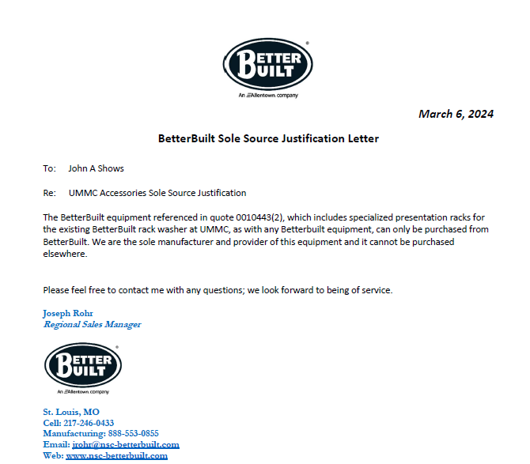

Attachment B

SUBMITTED IN RESPONSE TO
Sole Source Certification No. SS5856
Accepted until April 10, 2024 at 3:00 p.m.

I certify that the information contained in this objection is true and accurate to the best of my knowledge. I understand that UMMC will investigate all statements made in this objection and that any false or misleading information provided may result in adverse action.

__________________________________
Objector Name
Objector’s title

__________________________________
Date

