January 25, 2024

Re: Request for Brand Specific Specification Approval

I am writing to you to request a brand specific specification approval.

We have received several grants to conduct acoustic telemetry work on fish in the Mississippi Sound. To conduct this work, fish will be tagged with acoustic transmitters, and acoustic receivers will be strategically moored out in the Mississippi Sound to passively monitor presence and movement of the tagged fish.

In order to complete the work required of these grants, we request the authority to purchase the brand specific equipment from AMIRIX Systems Inc./Vemco. We propose to make several purchases over the next two years, with the first purchase occurring upon approval.
A maximum of the following would be purchased:

- 182 V13-1x-A69-1604; Rounded Case
- 15 V16-6x-A69-9001; Rounded Case
- 25 V9-A69-1604; Rounded Case
- 1 Magnetic Activation Probe for Acoustic Receivers
- 4 NexTrak R1- Transponding Acoustic Receiver
- 17 NexTrak R1 – Transponding Acoustic Receiver
We are requesting to use Vemco products because we currently have an array developed throughout the Mississippi Sound using this brand (n=65, with an additional 140 about to be deployed). These upcoming projects will add to that infrastructure to create a more thorough coverage of the array. As these acoustics projects continue our goal is to have a complete array throughout the Mississippi coast. It is therefore imperative that we use consistent and compatible equipment. By changing brands, we would lose continuous coverage and our fish are only detectable on a portion of the array. If we had to use another product, we would have to replace the currently established array to achieve continuous coverage.

An additional benefit to using this product is that many colleagues in the northern Gulf of Mexico region also use this product. Therefore, the transmitters we use on our fish are compatible with the Vemco receivers that our colleagues have deployed, and through our data sharing efforts we enhance our detection area. This compatibility and collaborative effort results in greater refinement of our resultant data.

In the past we have tried using equipment from the comparable company, Lotek/Sonotronics. However, it is resoundingly apparent that Vemco’s product was far superior. The Lotek product requires that the receiver be removed from the water and opened, exposing the batteries and computer, in order to download the recorded data or change the batteries (only 7 month life). This monthly at sea exposure is a major source of potential water fouling, causing shorting of the computing system and loss of the data.
Vemco on the other hand provides wireless download capabilities that maintains the integrity of the internal computing system and has a 15 month battery life, further reducing the number of times the housing needs to be opened. Also, with the Lotek product we had over 50% of the receivers crack and
flood while deployed, which destroyed the data and resulted in the purchase of new equipment for replacement. This increased the costs of the project to levels beyond what was budgeted and resulted in an inconsistent dataset.

We greatly appreciate your consideration of this brand specific bid request as the superior quality of the AMIRIX Systems Inc./Vemco product and compatibility with our colleagues’ arrays makes it ideal for the goals of these projects.

Please let me know if you need any more information to approve this request. Sincerely,

Jill Hendon Director
Center for Fisheries Research and Development
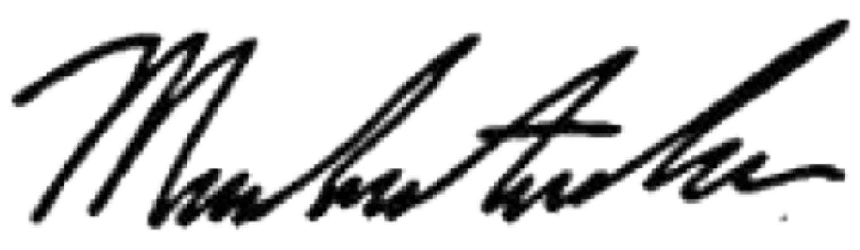

Michael Andres
Assistant Research Professor Department of Coastal Sciences

Gulf Coast Research Laboratory
703 East Beach Drive • Ocean Springs, MS • 39564
Phone (228) 872-4242 • Lab (228) 872-4257 • Fax (228) 872-4219
E-mail: jill.hendon@usm.edu • http://www.usm.edu/gcrl/fisheries_center/shark.research.program.php

