

STATE OF MISSISSIPPI
GOVERNOR PHIL BRYANT

DEPARTMENT OF FINANCE AND ADMINISTRATION
LAURA D. JACKSON
EXECUTIVE DIRECTOR

July 31, 2026

Caroline Clemmons - FAX #360-4650
ATTENTION: LEGAL ADS - The Clarion Ledger
201 South Congress
Jackson, MS 39201
Email: cllegals@clarionledger.net

RE: GS# 109-210
School of Medicine (UMMC Simulation Center Audio/Visual Equipment)
University Medical Center
Jackson, MS

Dear Sir/Madam:

We are hereby e-mailing two pages, one of which is an Advertisement for bids covering the referenced project on which bids are scheduled to be received at 2:00:00 p.m. on Tuesday, 10/31/2017.

Please publish this Legal Notice in your paper on 10/05/2017, and 10/12/2017, and furnish this office with three copies of the Proof of Publication, along with your statement.

We understand no hard copy is necessary and request that you return to us, by e-mail, a confirmation of this advertisement.

Sincerely,

BUREAU OF BUILDING, GROUNDS AND REAL PROPERTY MANAGEMENT

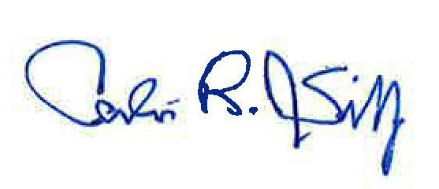
Calvin R. Sibley
Director

CS/mw

Enclosure
cc: Associated Builders & Contractors (e-mail)
Associated General Contractors (email)
Dodge Data & Analytics (e-mail)
Memphis Plan Room (e-mail)
New Orleans Publishing Group (e-mail)
Reed Construction Data (e-mail)
Statewide Plan Room of Mississippi (e-mail)

501 NORTH WEST STREET, SUITE 1401 B ∙ JACKSON, MISSISSIPPI 39201 ∙ TEL (601) 359-3621∙ FAX (601) 359-2470

