Amendment One To:
Request for Proposals
RFx No. 3120000986
Smart No. 1450-17-R-RFPR-00001
Comprehensive Ecological Risk Assessment and Land Use Management Planning
Pre-Proposal Meeting Minutes
Questions and Answers

Mississippi Department of Marine Resources

1141 Bayview Avenue

Biloxi, Mississippi 39530
Contact: Erin Gallagher – Procurement@dmr.ms.gov

THIS IS AMENDMENT ONE TO THE REQUEST FOR PROPOSALS. YOU MUST ACKNOWLEDGE THIS AND ALL FUTURE AMENDMENTS ON THE CERTIFICATIONS, ASSUSSURANCES AND AMENDMENT FORM (ATTACHMENT E) OR, IF YOUR PROPOSAL HAS ALREADY BEEN SUBMITTED, BY LETTER. YOUR ACKNOWLEDGMENT OF ALL AMENDMENTS MUST BE RECEIVED BY THE MDMR BY THE DEADLINE FOR RECEIPT OF YOUR PROPOSAL.

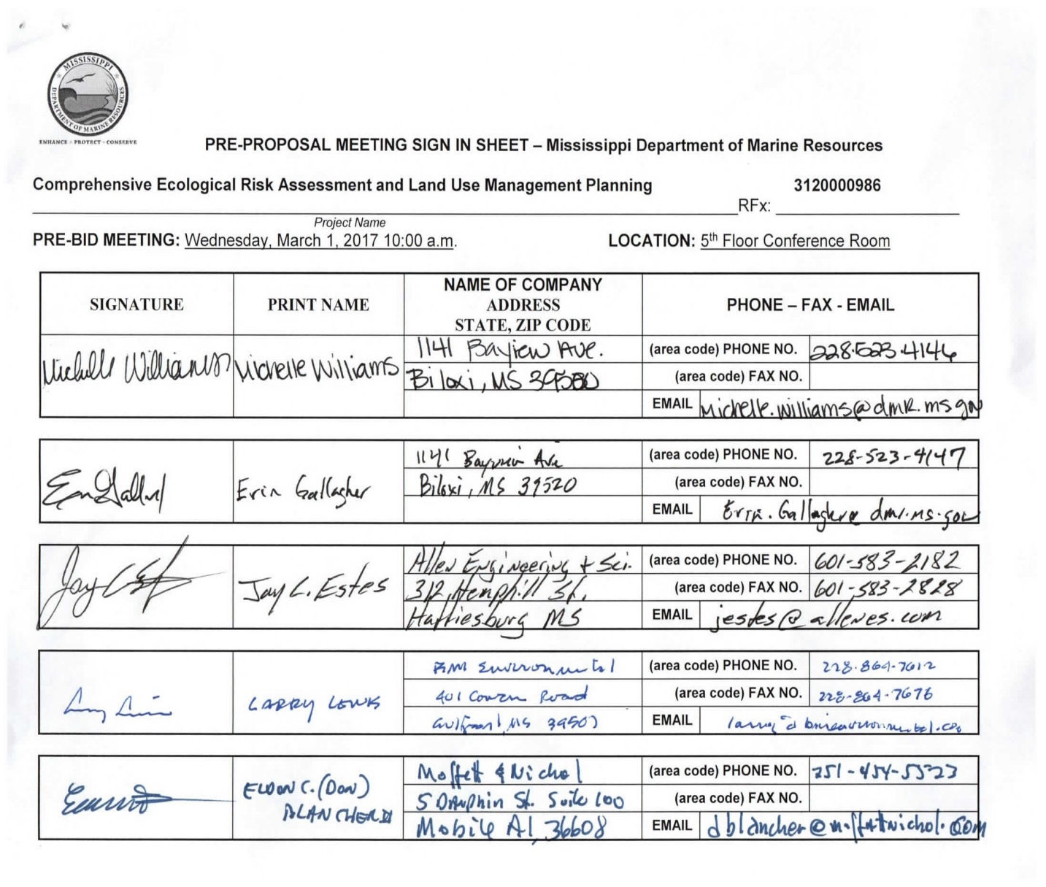

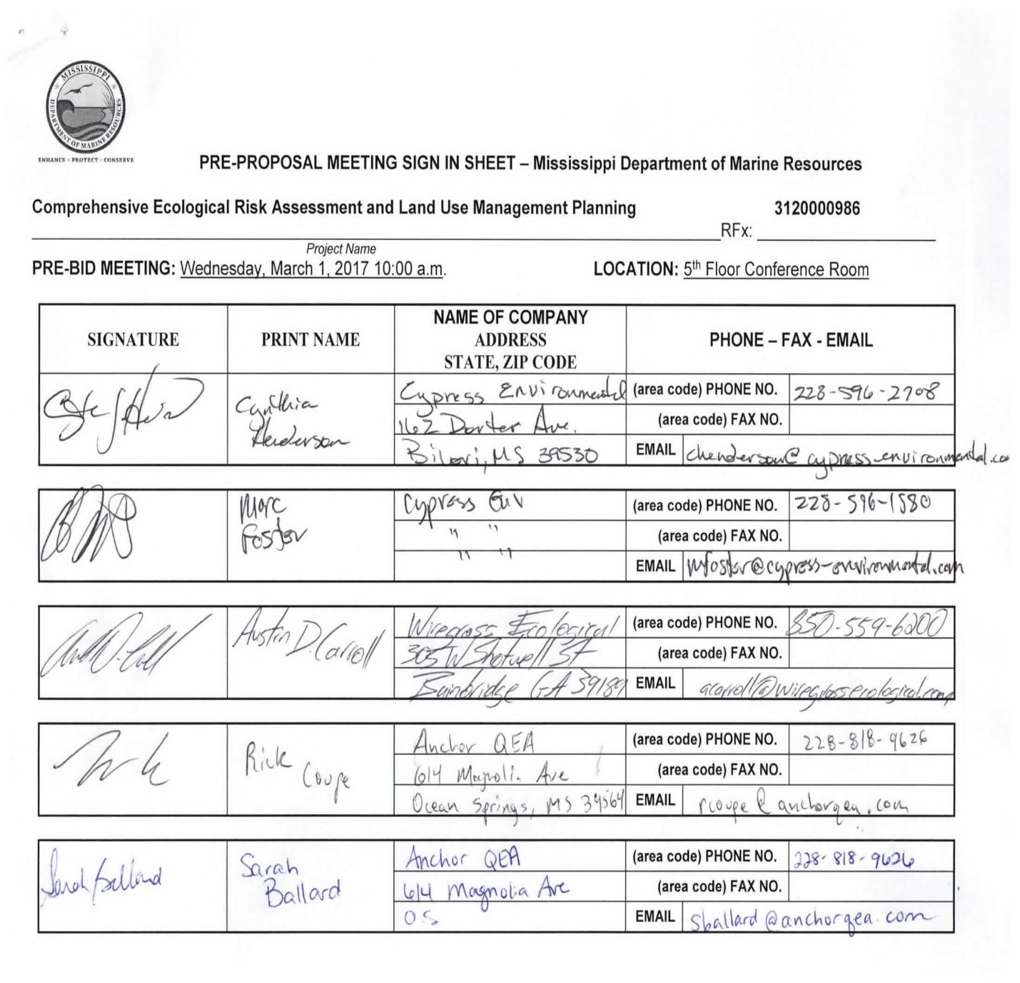

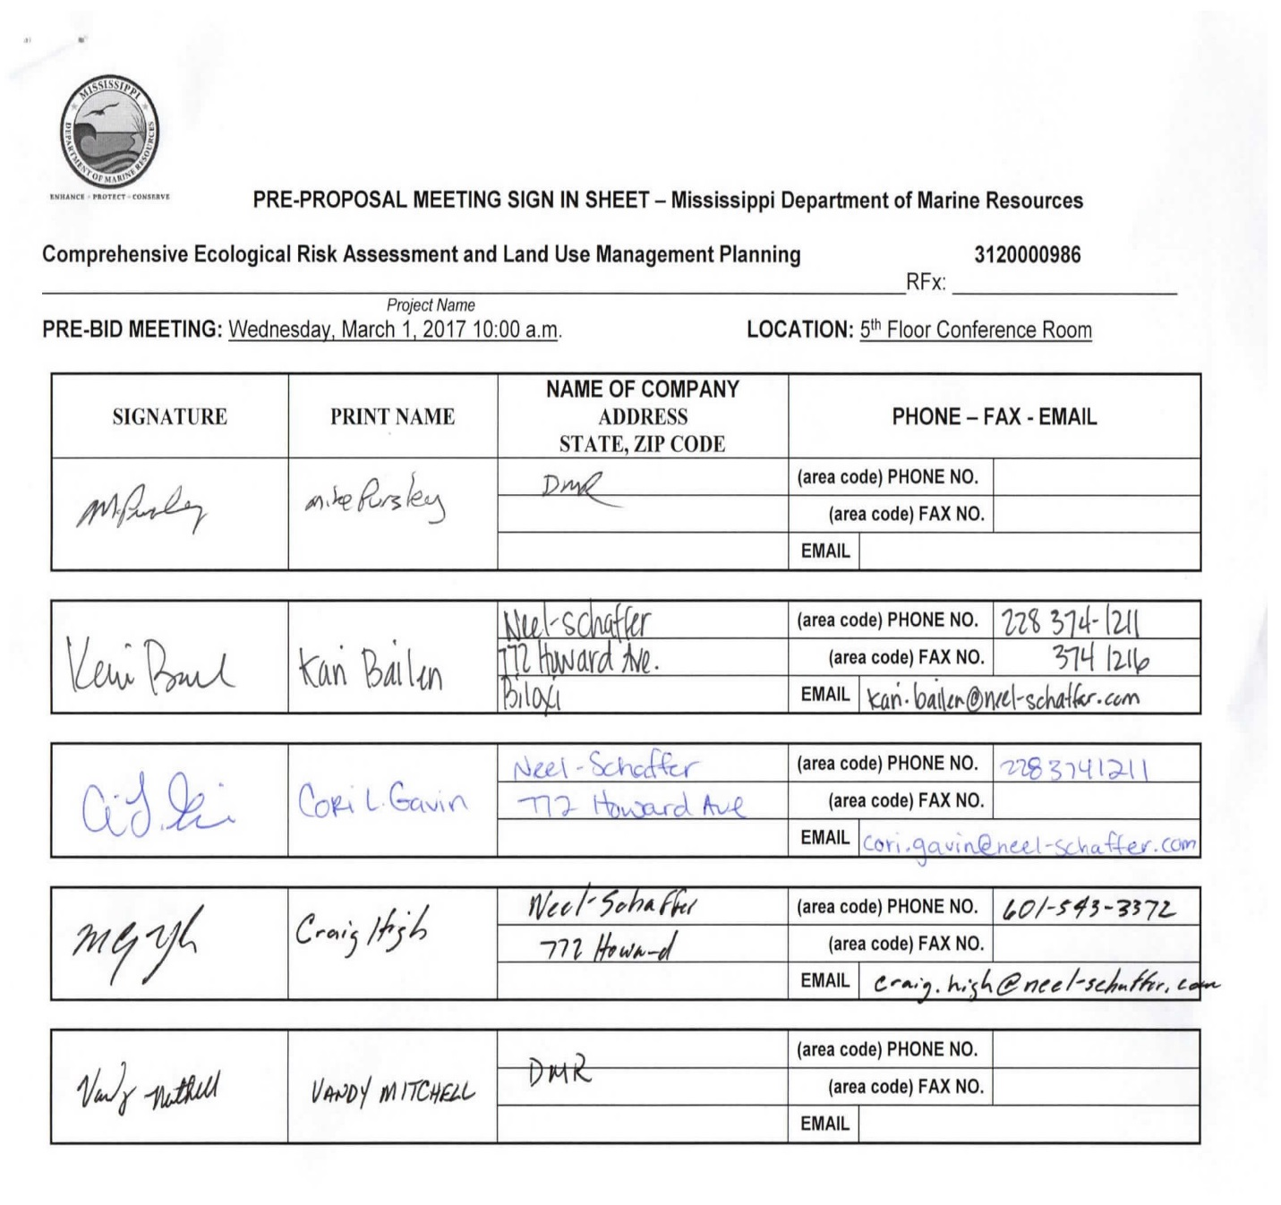

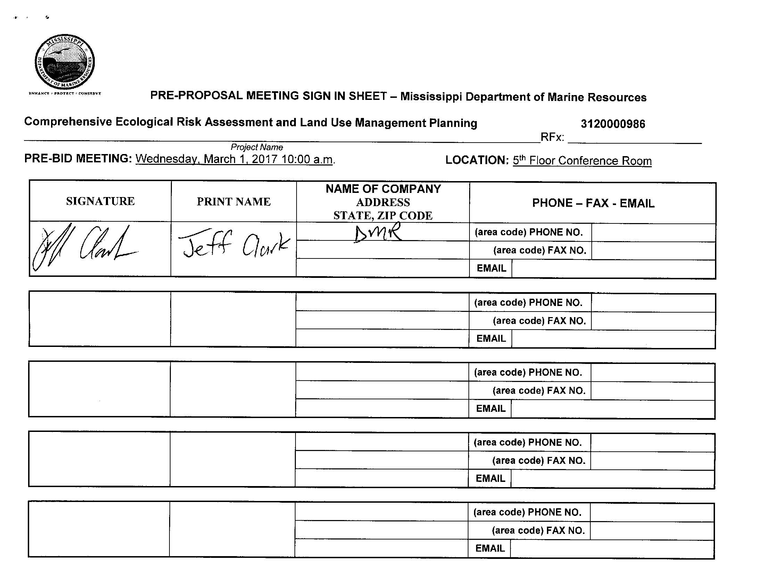

- Has there been any addendum?
- No
- I have a basic question on the administrative part of it. The format that is listed has eights part, there again the order seems to be a little different in the past or with others. Is there a requirement that they follow?
- No, it is outlined in RFP in that order because it is easier for the evaluation committee to review proposals when the proposals are in the same order. However, it is not mandatory and will not be penalized for not following the format.
- Your proposal must have all required information as listed in the RFP, but you may change the order of the information.
- Is there a requirement for font size?
- No
- The RFP mentioned specific timelines like so many months or days for deadlines for completion of projects. Are those going to strictly adhere too?
- These can be changed as we go along. The deliverable deadlines are flexible, and may be extended at the discretion of the MDMR Program Manager.
- Phase 1 write up, the expectation of taking inventory of those you have identified or new Coastal Preserves assessment parameters.
- Coastal Preserve staff will work with the contractor, using existing data and information, to identify the assessment parameters.
- Will there be 13 different plans?
- Yes
- It says it is a 5-year project, but you have it outline Phases 1 through 4 which is a 4-year contract. Typically, contracts are 4 years plus an extension. Is this in case you don’t finish or is there expectations that there will be more money to come?
- The funding source is a five-year grant. It is written Year 1 through 5, but years 3 and 4 are basically the same work that are lumped into a single phase.
- The money comes from an annual grant from NOAA. The amount is similar each year, but may be a thousand or two off from what is listed.
- My question is the contract board usually issues only a 4-year contract with a1 year extension.
- The reason we did a one-year with four options to renew, is because the funding is yearly. We feel certain we will get it but as a disclaimer we put the information in the RFP that funding is based on availability and that it is a one year contract with 4 options to renew.
- You don’t expect any increases or any additional monies?
No
- Phase three you divided into two years in this five-year proposal, the second year being 2018, third year being 2019, and the fourth year being 2020. Is Phase 3 taking place with Phase 2 or Phase 4 for it to be divided into two years? The way I read this is the third and fourth year would be 2019 and 2020 on the timeline. This was this reads is confusing.
- The dates under Phase 3 indicate only one year -2019 (although it’s actually 2 years of work and should have stated years 2019 & 2020). The dates listed under Phase 4 are for year -2020 (which indicates that Phase 4 would start one year after Phase 3 started). Phase 4 should have indicated year 2021 (the 5th year of the project). The project is 5 years and the NOAA funding is for 5 years. The answer to the question is “no”, Phases 3 and 4 will not occur simultaneously.
- During the risk assessment site field visits, will Coastal Preserves staff assist us in these visits?
- Yes, the staff will be working closely with you.
- Stakeholder groups, would that be something you’ve identified, presently identify, will identify or is that something we need to identify?
- It is something that we will work together to identify the stakeholders.
- Does DMR/Coastal Preserve staff already have sampling plans and field activities developed for the preserves that you would like to see fulfilled for these assessments or are we going to be solely responsible for the field work necessary to go out and do this?
- Again, the staff will work closely with you guys or whoever gets the contract. The idea is to formalize what resources we have out there, what threats are to those resources, and what we need to do to protect those resources. It will be a joint effort.
- Pricing, you guys have a grant for this. I am assuming a fixed amount, but you have also asked for price in the submittal. How much is that going to weigh in on the selection?
- Pricing is worth 20 points.
- I understand a fixed amount in the grant. In the RFP you talk about areas not to exceed, is that fixed or could you, if your best professional judgement, say we are going to need more resources (as in personnel for one task and not the other) would you be penalized if you adjusted according in the not to exceed amount?
- NOAA has funded a certain amount of money. These are the funds that NOAA has approved for this project.
- You will not be able to go over the not to exceed amount for each phase.
- Phase 3, number 4, the second sentence says, “areas without acreage will not have management plan, but if possible a baseline assessment should be conducted.” What is that eluding too?
- Only the 13 sites identified in the RFP are required. Baseline assessments on the other sites would be conducted if the contractor can do them without incurring any additional costs.
- Are you saying that there is a possibility that the scope of work will increase without any changes in the fee proposed?
- We would not be able to increase the scope without the contractor and MDMR agreeing on the change.
- Basically, if you are able to complete deliverables using less time and resources than you anticipated, and finish faster, that could be used to do a baseline on these other sites.
- What kind of contract are looking for here lump sum kind of expenses?
- Firm fixed price. The contract will be for a period of one year, and the contractor may invoice for services rendered on a monthly basis. Unless otherwise required by NOAA, the contractor may invoice quarterly if preferred.
- If it is lump sum, are you looking at quarterly payments or 50% complete, 50% invoicing?
- We can process invoices as frequently, monthly or quarterly (if preferred as stated above). You still would need to give percentages for services. And the contractor may only invoice for services that have been completed within that invoicing period.
- Is the data we are using existing or are we going to be working with staff to obtain additional data?
- It is essentially working with existing data or existing data/information that is out there and not going out and collecting your own data.
- If we find data gaps, would it be beneficial to fill those data gaps if it feasible?
- Yes, one of things is to identify those data gaps.

