Amendment One To:
Request for Applications
RFx No. 3140001085
Smart No. 1450-18-R-RFQI-00003
National Estuarine Research Reserve (NERR) Internship
Work Schedule Revision

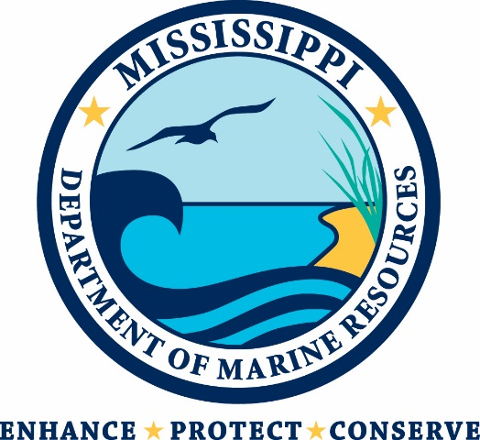

Mississippi Department of Marine Resources

1141 Bayview Avenue

Biloxi, Mississippi 39530
Contact: Valerie McWilliams, Procurement Specialist-Procurement@dmr.ms.gov

THIS IS AMENDMENT ONE TO THE REQUEST FOR APPLICATIONS.

Question: Is 40 hours a week the absolute requirement? Is work needed for Sundays?

Answer: Work hours for the NERR Intern position have been revised. The work hours for this position will now be 20-40 hours per week (a minimum of 20 hour per week, and a maximum of 40 per week).
Regular hours are Monday-Friday, and may include occasional work hours on weekends depending on the needs of the Department, and the intern’s school schedule.
The position’s supervisor will make the final determination in scheduling the Intern’s weekly hours.

