Amendment One To:
Invitation for Bids
RFx No. 3160001424
Smart No. 1450-17-R-IFBD-00007
Lee Street Concrete Culvert Deployment
Pre-Bid Meeting
Questions and Answers

Mississippi Department of Marine Resources

1141 Bayview Avenue

Biloxi, Mississippi 39530
Contact: Erin Gallagher – Procurement@dmr.ms.gov

THIS IS AMENDMENT ONE TO THE INVITATION FOR BIDS. YOU MUST ACKNOWLEDGE THIS AND ALL FUTURE AMENDMENTS ON THE BID FORM (ATTACHMENT B) OR, IF YOUR BID HAS ALREADY BEEN SUBMITTED, BY LETTER. YOUR ACKNOWLEDGMENT OF ALL AMENDMENTS MUST BE RECEIVED BY THE MDMR BY THE DEADLINE FOR RECEIPT OF YOUR BID.
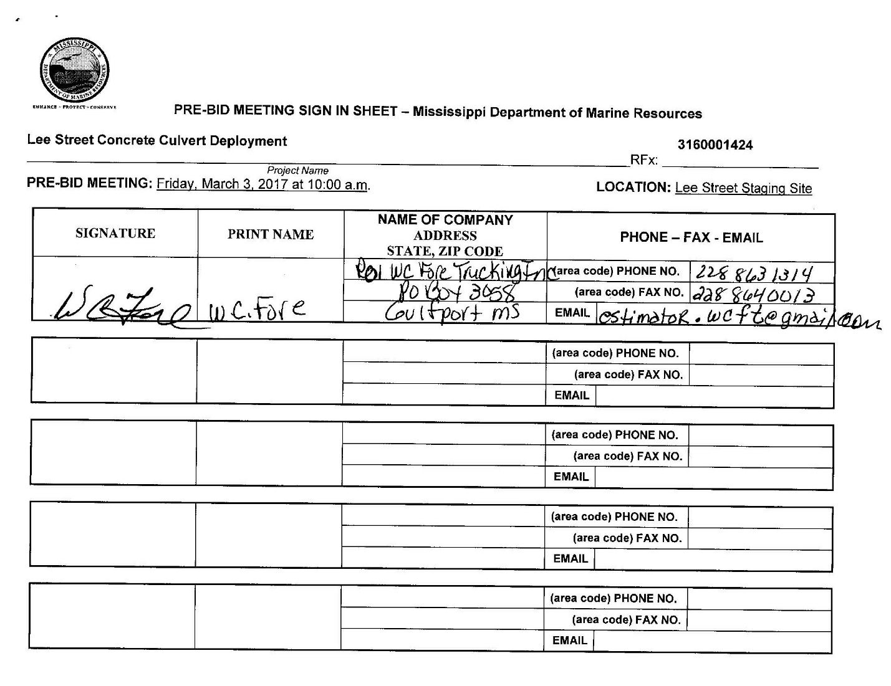
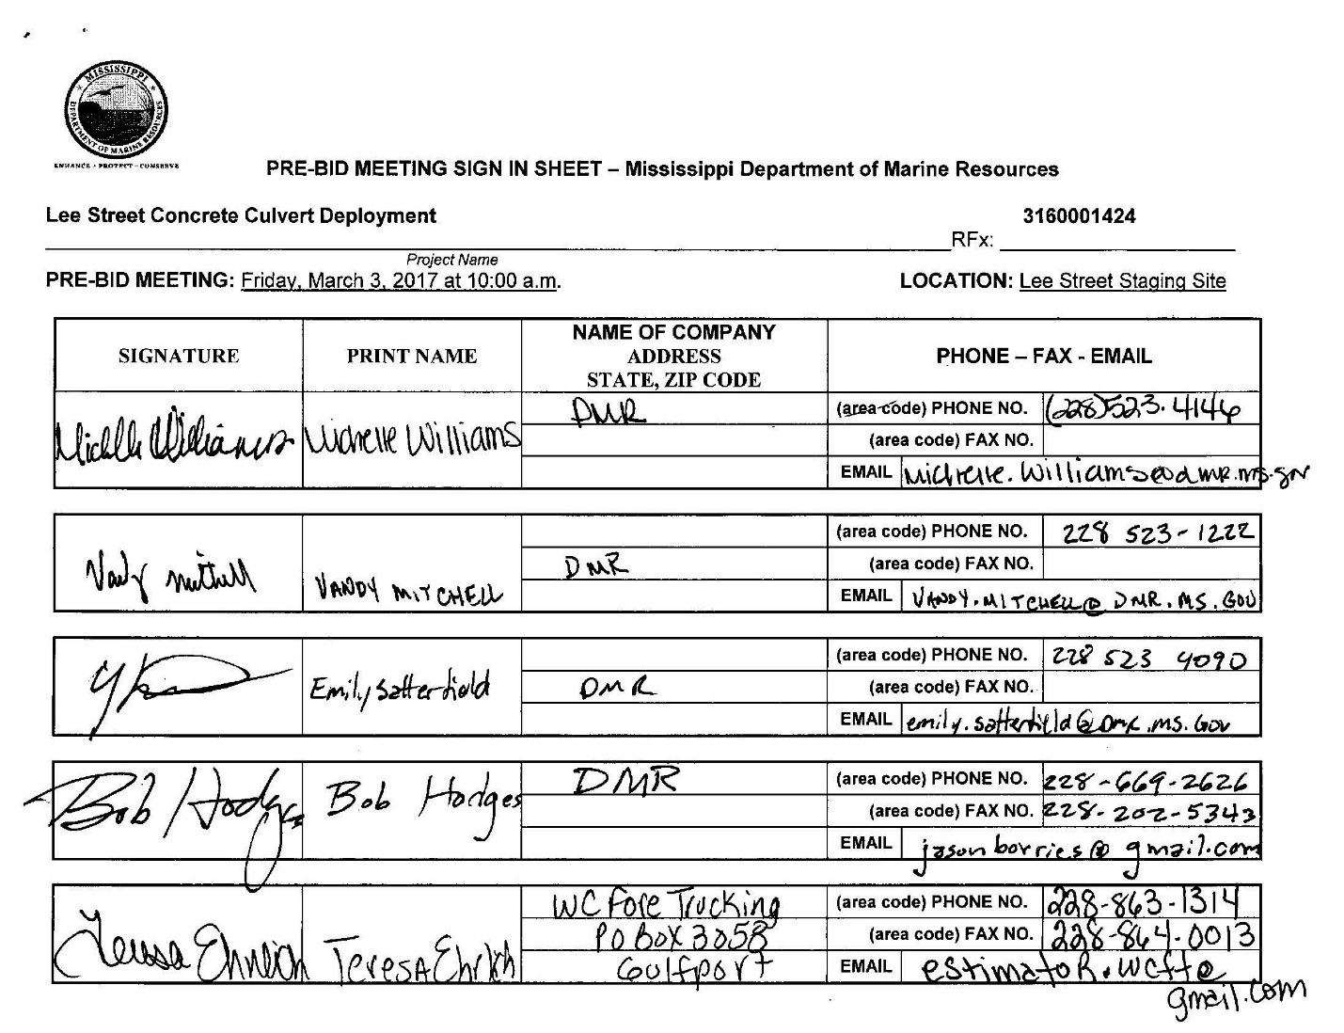
- When we deploy the material, will we be able to deploy the entire barge on that trip?
- Yes, you will be able to deploy the entire barge.

- How much water is in the loading zone?
- There is about 6 feet now. There will be about 8 feet in the next couple of months.

- How many total tons are you looking to deploy?
- We are looking for as much material as you can deploy at this staging site that is within our budget.

- Once we have loaded the bigger material (culverts and boxes), can we bring in a front-end loader to pick-up the smaller material?
- We are only looking for mostly the bigger material such as the pipes and boxes.

- Are we able to pull the rift-raft back so it doesn’t punch a hole in the bottom of the barge?
- We are currently checking with Coastal Zone Management. We do not have a definitive answer. Once we have an answer, we will let all known bidders know what has been determined.

- Can the boat at the harbor to the right of the loading zone be moved?
- Yes, we can work with the harbor master.

- The cloth on the end of the pipes, does it have to be removed?
- No, it can be deployed with the material.

