Billy Beard
Staff Officer II, Bureau of Fleet Management
Office of Purchasing, Travel and Fleet Management
State of Mississippi
701 Woolfolk Building, Suite A
501 North West Street
Jackson, MS 39201
Dear Billy Beard:
This is a proposal to show ROK Brothers Inc. interest in entering into a state contract with the State of Mississippi to provide Raybestos Brake and Chassis products, VDO TPMS sensors, and Panorama Antennas. Following is the requested information:
ROK Brothers Inc.
Physical Address:
8201 Cloverleaf Drive
Millersville, MD 21108

Mailing Address:
PO Box 381
Millersville, MD 21108

Phone: (800) 914-3334
Fax: (800) 635-1335
Email: info@rokbrothers.com
Website: www.rokbrothers.com

Pricelist and Discounts: Uploaded

Price Guarantee: Discounts will be firm for 12 months.

Transportation Terms: F.O.B

Payment Terms: Net 45 days. Invoices to be submitted electronically.

Distribution: ROK Brothers Inc. is an authorized distributor of Raybestos Brand product, VDO TPMS Sensors, and Panorama Antennas. Products will come from shipping locations in Maryland, Pennsylvania, Illinois and Texas.

Purchase Summary: Uploaded.
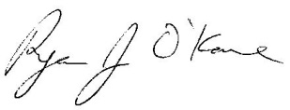
________________________
Ryan J. O’Kane
President

