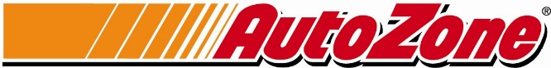
AutoZone
123 S. Front Street
Memphis, TN 38103

August 14, 2017

Mr. Billy Beard
Staff Officer II
Office of Purchasing, Travel and Fleet Management
701 Woolfolk Building, Suite A
501 North West Street
Jackson, MS 39201

RE: RFx 3130000392 Automotive Parts and Equipment

Dear Mr. Beard,

Thank you for the opportunity to provide the State of Mississippi with a formal response to RFx 3130000392 outlining AutoZone’s Automotive Parts and Supplies capabilities. On behalf of everyone at AutoZone and our Public Sector sales division, it is our sincerest desire that the State of Mississippi will recognize the value, convenience and savings represented by the AutoZone’s proposal. We believe that AutoZone is capable of providing our public sector customers with a total procurement solution that provides maximized value for your agency.
As requested, I have included the following information:

- Payment Terms – Net 45 Days
- Distribution – Product is routed from AutoZone stores, directly to the government agency, by AutoZone employees
- Minority Vendor Status – AutoZone does not have a minority status

AutoZone is the largest retailer of aftermarket automotive parts in the United States with over 5000 company owned stores and more than 65,000 employees. We sincerely believe that our program offering is the best in the industry. Please feel free to contact our public sector support team for any questions or requests that you have.

Most Respectfully Yours,
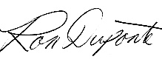
Ron Duponte
National Business Development Manager
ronald.duponte@autozone.com
Phone 570-807-9087
www.autozonepro.com

