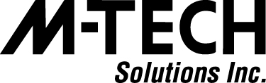

6128 W Sahara Ave. Las Vegas, NV 89146 PH 828-243-8697 www.Lenak@m-techsolutions.com

October 26, 2016

Thomas Dent
Operations Manager
NGV Solutions, LLC
5495 Lakeland Drive
Flowood, MS 39232

RE: Authorization letter for contract with State of Mississippi

Dear Thomas Dent,

Please accept this letter as our approval, authorizing NGV Solutions, LLC to enter into a contract with the State of Mississippi on behalf of M-tech Solutions Inc.

Sincerely,
Yelena Kovalchuk
Project Manager/Sales Manager
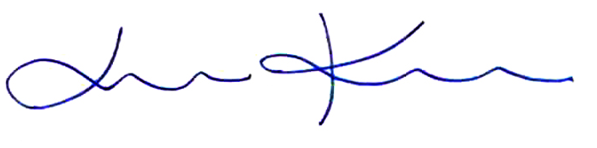
(828) 243-8697
Lenak@m-techsolutions.com

M-tech Solutions Inc.
464 Governors View Rd.
Asheville, NC 28805
(Mailing/Billing address)

M-tech Solutions Inc.
6128 W Sahara Ave.
Las Vegas NV 89146
(Coorporate address)

