REQUEST FOR APPLICATIONS
Finfish Contract Worker Position

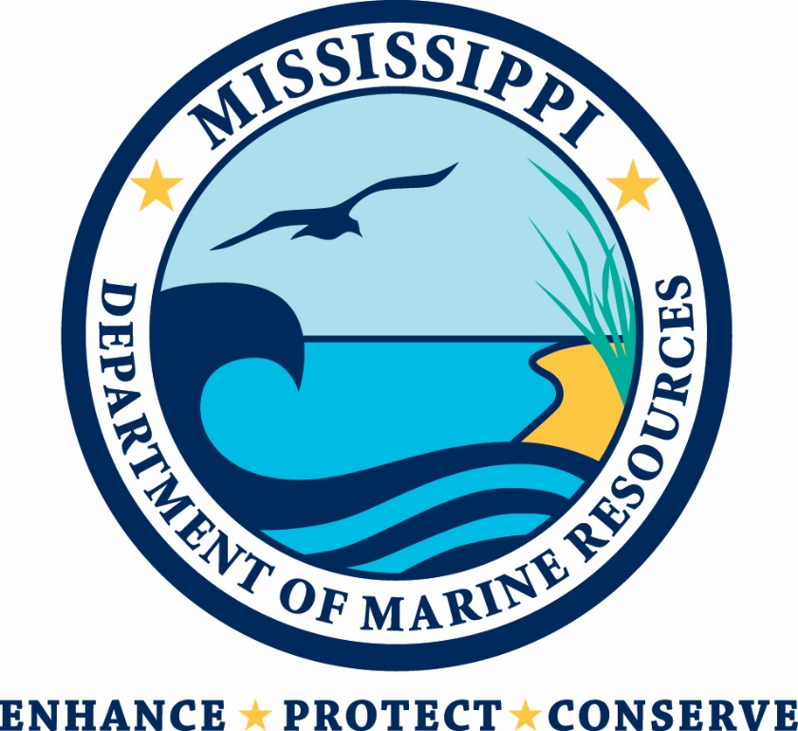

Mississippi Department of Marine Resources
1141 Bayview Avenue
Biloxi, Mississippi 39530

Contact: Michelle Williams - procurement@dmr.ms.gov

Introduction
The Department of Marine Resources is currently seeking two contract workers for the Marine Fisheries Finfish Bureau.
The MDMR manages all marine life, public trust wetlands, adjacent uplands, and waterfront areas to provide for the balanced commercial, recreational, educational, and economic uses of these resources consistent with environmental concerns and social changes.

Scope of Work/Job Duties
The contract worker will assist in the National Fish and Wildlife Foundation observer program for the recreational for-hire (charter) sector to assess landings, discards and associated reporting biases. Duties will require that observer trips be taken each month aboard recreational for-hire vessels operating out of Mississippi coastal harbors. Duties will include assisting the Finfish Bureau of the Marine Fisheries Office by collecting recreational fishing information through the expanded fishery dependent data collection survey. Duties will also include utilizing standardized SEAMAP vertical line methodologies to collect Red Snapper and reef fish species in the assigned survey area. Additional duties include, but are not limited to: processing fish samples brought into the MDMR laboratory (i.e. fish weight, length, remove otoliths and other samples as required); assisting in field work needed for biological assessments; operating fisheries vessels; and, performing other duties as assigned by the supervisor and/or Office Director.

Minimum Qualifications
The minimum qualifications which the MDMR is seeking for these positions include:
- Education: Graduation from a standard four-year high school or equivalent (GED or High School Equivalency Diploma); and,
- Experience: Two (2) years of experience related to the described duties, such as trailering and operating marine vessels.
- Substitution Statement: Related education and related experience may be substituted on an equal basis.
- Other: Must possess a valid Mississippi driver’s license or driver’s license from another state (Mississippi residents must have a Mississippi driver’s license). MDMR will verify the driver’s license.

Compensation and Hours Worked
This position pays $16.00 per hour, and are for 40 hours per week.
Instructions for Applying
- Complete and sign the attached Application (all requested information must be completed).
- Attach your resume describing your education and prior work history, including relevant work experience.
- Attach a list of at least three references (name and current contact information). References familiar with your job performance skills are preferable. If MDMR is unable to contact your references based upon the contact information you provide, your application may be rejected.
You may submit your application packet (all of the above) in one of three ways:
- Via email to procurement@dmr.ms.gov;
- Via U.S. mail, postage prepaid, to:
  - Erin Gallagher, Director of Procurement, Mississippi Department of Marine Resources, 1141 Bayview Avenue, Biloxi, MS 39530; or,
- Via hand delivery to Erin Gallagher at the above address.
The deadline for receiving applications is February 8, 2017 at 10:00 a.m. Late applications will not be accepted.
You may be required to interview in person at MDMR in Biloxi, Mississippi, or by telephone.
Questions/Requests for Clarification
All questions and requests for clarification must be submitted by email to:
Michelle Williams, Contract Analyst
procurement@dmr.ms.gov
The MDMR will not be bound by any verbal or written information that is not specified within this Request for Applications unless issued in writing by the contact person.
Equal Opportunity Statement
MDMR will select the vendor for these services without regard to political affiliation, race, color, handicap, genetic information, religion, national origin, sex, religious creed, age, or disability.

