Rankin County School District
Brandon, Mississippi

REQUEST FOR BID PROPOSALS
SMALL KITCHEN EQUIPMENT
BID# CN1804

REQUEST FOR BID PROPOSALS

SMALL KITCHEN EQUIPMENT

SECTION/TITLE PAGE

1.0 PURPOSE……………………………………………………………………………………………….……………………… 3
2.0 GENERAL CONDITIONS OF BID……………………………………..……………………………………………… 3
3.0 BID AND CONTRACT REQUIREMENTS.............……………….……………………………………………. 3
4.0 STATEMENT OF ASSURANCES AND COMPLIANCES……………………………………………………… 8
5.0 STATEMENT OF CERTIFICATION……………………………………………………………………………………. 9
6.0 INSTRUCTIONS FOR SUBMITTING BID………….………………………………………………………………. 10
7.0 TIMETABLE/RESPONSE SUBMITTAL…………………………………………………………………………….. 10
8.0 SMALL KITCHEN EQUIPMENT ITEMS WORKSHEET…………………….…………………………………. 11
9.0 PROPOSAL DOCUMENTATION CHECKLIST……………………………………………………………………. 39

- PURPOSE
The purpose is to solicit bids for small kitchen equipment for the Rankin County School District, Office of Child Nutrition. This bid is a BRAND NAME OR EQUAL line item GRAND total dollar amount bid. All terms and conditions shall be met. Bids are due May 16, 2017, prior to 2:00p.m. Bid opening is May 16, 2017 at 2:00p.m.

- GENERAL CONDITIONS OF BID
  - Delivery to 25 sites.
  - Delivery charge to be INCLUDED in price quotations.
  - Substitutions to be approved by Child Nutrition Office prior to delivery.
  - Bid quantities will be met as nearly as possible based on budgetary guidelines.
  - Prior 10-day approval of equal brands required.
  - Substitution without prior approval is cause for disqualification of entire Bid.
  - Orders SHALL be addressed to (and delivered to) cafeteria managers.
  - Rankin County School District will not be responsible for merchandise delivered to location other than cafeteria and signed for by unauthorized parties.

- BID AND CONTRACT REQUIREMENTS
  - DELIVERY OF BIDS: The Rankin County School District will receive sealed, competitive bids in the Administrative Office Building, 1220 Apple Park Place, Brandon, Mississippi, 39042, as per the date and time specified in Section 7.0, at which time the bids will be publicly opened, read aloud, and taken under advisement. All bids must be received on or before the date and time specified in Section 7.0, neither the dating of the bid nor placing it in the mail by this date will meet the legal requirements pertaining to this bid. Any bid received after the bid opening date shall be marked “LATE BID” and returned to the bidder unopened.
  - ADDENDUM’S: No Addendum’s will be issued five (5) working days prior to the bid opening date listed in Section 7.0.
  - LINE ITEM GRAND TOTAL DOLLAR AMOUNT BID: For bids to be considered complete, all bidders are required to submit bids on ALL item(s) listed on this bid. A grand total shall be computed from all items. If any bidders do not submit a bid on all item(s), said bid shall be considered incomplete and rejected.
  - QUANTITIES: It shall be understood that any contract established as a result of the Request for Proposal will not obligate Rankin County School District to receive any quantity in excess of actual requirements. The quantities shown are estimates and result from actual historic tabulation. Rankin County School District will make a reasonable effort to fully utilize projected supplies of items placed in inventory specifically for the district. Within ten (10) days after award of contract, the successful bidder and the district shall agree on those items that fall into this category.
  - PROPER EXECUTION: All bids must be submitted in accordance with Section 31-7-13 of Mississippi Code of 1972 as amended, and must be properly executed signed by a responsible officer or employee of the bidder. All bids must be typed or written in ink, any alterations or changes that are made must be initialized by the person who signs the BID PROPOSAL FORM. Bids should be checked before submission for accuracy and correctness since the Rankin County School District WILL NOT be responsible for any errors for which the bidder is responsible.
  - BID WITHDRAWAL and MODIFICATION: Bids may be modified or withdrawn by written notice from or in person by the Bidder, if received in the office of the Director of Purchasing, twenty-four (24) hours prior to the bid opening date and time set forth in the BID OPENING SCHEDULE. NO WITHDRAWALS WILL BE ACCEPTED BY TELEPHONE. If a bidder withdraws his bid, all documents shall remain in the possession of the Rankin County School District, marked as withdrawn, and included in the permanent file of that bid number.
  - RIGHT TO REJECT BIDS: The Rankin County School District reserves the right to reject any and/or all bids or any groups thereof and waive formalities.
  - DAMAGE OR LOSS:
    - Any damage or loss to the Rankin County School District’s property as a result of any action by the successful Bidder in the execution or performance of any item or service in this bid, shall be repaired to the satisfaction of the Rankin County School District, at the Bidder’s expense, within a reasonable time set forth by the Rankin County School District.
    - The successful bidder shall hold the Rankin County Board of Education, Rankin County School District, it’s Officers, Agents, Employees harmless from liability of any nature or kind whatsoever, because of use of publisher or author, manufacturer or agent of any copyrighted or uncopyrighted composition, secret process, patented or unpatented invention, article, environment-sensitive material, or appliance furnished or used under this bid.
  - LABELING OF BID: It is very important that the BID PROPOSAL FORMS be delivered in an envelope clearly marked in the lower left-hand corner with the following information:
SEALED PROPOSAL
DATE (Date the bid is submitted)
BID# CN1804
BIDDER’S NAME
Bid Section 8.0, “SMALL KITCHEN EQUIPMENT ITEMS WORKSHEET”, shall be placed in a sealed envelope. The envelope shall be marked with company name and Bid Number on the outside of the envelope.
  - BIDDER QUALIFICATION: Only qualified companies will be allowed to offer bids.
The following criteria must be met before a potential bidder is qualified:
    - Product Line – The potential bidder shall provide proof that the items listed in Section 8.0 are in stock or can be obtained within two (2) weeks from order date & specialty items up to four (4) weeks from order date. Purchaser reserves the right to disqualify the bid if terms are not met. (Excludes 5 compartment trays)
    - Capacity – A bidder must clearly demonstrate to school district officials that he has the capacity, physically and financially, to supply items to the school district in economical quantities as required. When distributor stock numbers are not available, distributor must show written proof that he will be able to supply items. Those items not available should be available within fifteen (15) working days of the bid award.
    - Reliability – A successful bidder must have a proven (or believable) record of service particularly with respect to delivering all items on a regularly scheduled basis, at favorable prices. A DISTRIBUTOR MAY BE DESIGNATED AS UNACCEPTABLE IF THE REQUIREMENTS LISTED HEREIN HAVE BEEN PREVIOUSLY VIOLATED AND/OR POOR COMMUNICATIONS EXIST BETWEEN THE SELLER AND THE SCHOOL DISTRICT.
    - Financial Capacity – The potential bidder shall have financing adequate to purchase items in the economical quantities. At the request of the school district, the potential bidder shall provide three (3) written references to document adequate financial capacity.
    - Accounting Practices – A potential bidder must clearly demonstrate to school district officials the capability to provide accurate, reliable, and timely reports. Moreover, a potential bidder must demonstrate the capability to spontaneously provide data for periodic review of prices by school district officials.
    - Performance References – If the district has no historical records to document compliance with the requirements, three (3) letters of reference from other school districts shall be provided.

  - REVIEW AND AWARD:
    - After the public opening of the bids, school district officials will require a minimum of five (5) working days for review.
    - The school district will award the contract at the next regularly scheduled meeting of the school board after opening, or as soon thereafter as possible.
    - All bids shall be subject to verification of mathematical extensions and addition. If the errors on math and brands are within the tolerances described in the Request for Proposal, the line item grand total will be adjusted, and if the bid is still low, the bid disclosure procedures will continue.
    - Mathematical Accuracy of Proposal Offered – If less than ninety percent (90%) of the mathematical calculations are correct, the school district may elect to reject the bid. The following items will be classified as mathematical calculations:
- Any error in a line item total in conversion, addition, or multiplication which results in an incorrect extension will be counted as one error.
- Any error in addition to arrive at the line item total will be counted as follows: each 1% change in the line item will count as one error.
- Drivers and helpers shall deliver merchandise into designated storage areas. Neither drivers nor helpers shall be required to store merchandise on shelves.
- Drivers and helpers shall request the authorized school receiver, or the designated representative, to verify the accuracy of quantities of each item, brand and code numbers of each item, and condition of merchandise. A designated school receiver shall sign each delivery ticket/invoice. Variations from the norm, i.e., shortages, damages, etc., shall be noted on each ticket by the designated school receiver. The bidder shall not be required to issue credits for errors not detected at the time of delivery, except for hidden damage. Tickets shall be checked while driver waits. DAMAGED MERCHANDISE WILL NOT BE ACCEPTED.
- Special or intermediate deliveries shall be required only if a bidder fails to deliver a product on a regularly scheduled delivery, in which case the bidder shall make delivery within 24 hours or as otherwise requested by the Child Nutrition Director.

3.12 FISCAL FUNDING: If the effective dates of this contract extend beyond June 30 of the current fiscal year, it shall be understood that purchases in the next fiscal year are conditional on the receipt of federal and /or state funds. In the event of the discontinuance or a decrease in federal and/or state funds, the school district reserves the right to change the item identification, decrease the quantities, and/ or delete items.
  - PAYMENTS: All invoices for products received and inspected by the 25th day of the month will be paid following the monthly School Board Meeting, which is the second Wednesday in the month.

  - TERMINATION OF CONTRACTS: The district may terminate the contract, if the successful bidder fails to perform at the level specified in the contract document. The successful bidder may terminate the contract if the school district fails to meet the specified payment terms, or other conditions arise that prohibit the bidder from fulfilling contract obligations. Each party shall follow the procedure outlined below, if a contract is to be terminated:
Step 1 – Issue warning letter and outline violations(s) and length of time to correct the problem.
Step 2 - Issue Letter of Intent to Cancel Contract, if the problem is not resolved by given date.
Step 3 – Issue letter to cancel contract.
  - STANDARD CONTRACT CONDITIONS:
    - This contract shall be governed in all respects—as to validity, construction, capacity, performance, or otherwise—by the laws of the state.
    - Bidders providing service under this contract, herewith, assure the school district that they are conforming to the provisions of the Civil Rights Act of 1964, as amended.
    - Bidders shall comply with Executive Order 11246, entitled “Equal Employment Opportunity,” as amended by Labor regulations (41 CFR Part 60).
    - State Sales and Use Tax Certificate of Exemption form will be issued upon request. Sales tax shall be included in prices where applicable.
    - Shall comply with applicable federal, state, and local laws and regulations pertaining to wages, hours, and conditions of employment because of age, race, religious creed, sex, national origin, or handicap.
    - Bidder shall comply with all applicable standards, orders, or requirements issued under Section 306 of the Clean Air Act (42 U.S.C. 1857-h), Section 508 of the Clean Water Act (33 U.S.C. 1368), Executive Order 11738, and Environmental Protection Agency regulations (40 CFR Part 15), which prohibit the use under non-exempt federal contracts, grants or loans of facilities included on the EFPA List of Violating Facilities.
    - By signing this document the bidder certifies that this bid is made without prior understanding, agreement, or connection with any corporation, firm, or person submitting a bid for the same materials, supplies, or equipment, and is in all respects fair and without collusion or fraud. The bidder certifies that collusive bidding is a violation of federal law and can result in fines, prison sentences, and civil damage award.
    - MODIFICATIONS, ADDITIONS, OR CHANGES TO THE TERMS AND CONDITIONS OF THE INVITATION TO BID MAY BE CAUSE FOR REJECTION OF A BID. BIDDERS ARE REQUESTED TO SUBMIT ALL BIDS ON THE SCHOOL DISTRICT’S OFFICIAL FORMS. Bids submitted on company forms will be rejected. This includes computerized price lists.

[RETURN THIS PAGE]
- BIDDER’S STATEMENT OF ASSURANCES AND COMPLIANCES
The undersigned, as bidder, certifies that the general and special conditions of this bid have been read and understood. The bidder hereby provides assurance that the firm represented in this bid, as indicated below:
  - Will comply with all requirements, stipulations, terms, and conditions as stated in the bid document.
  - Currently complies with all applicable federal and state laws and regulations relative to non-discrimination in employment practices.
  - CERTIFICATION OF INDEPENDENT PRICE DETERMINATION: By signing the BIDDER’S STATEMENT OF ASSURANCES AND COMPLIANCES, the Bidder certifies, in connection with procurement, that they, to the best of their knowledge and belief:
a). That the price in Section 8.0 has been arrived at independently, without consultation, communication, or agreement, for the purpose of restricting competition & as to any matter relating to such price with any other Vendor or Bidder.
b). That unless otherwise required by law, the price has not been knowingly disclosed by the Bidder and will not knowingly be disclosed by the Bidder prior to the Bid Opening date and time specified in Section 7.0 directly or indirectly with any other Vendor or Bidder.
c). That no attempt has been made or will be made by the Bidder to induce any other Person or Bidder to submit a BID PROPOSAL for the purpose of restricting competition.
  - That the person as indicated on page 39, is officially authorized to represent the firm in whose name the bid is submitted.

COMPANY: ___________________________________________________
ADDRESS: ________________________________________________________
CITY/STATE: _____________________________________________ ZIP: _______________
TELEPHONE: ____________________________ FAX: ____________________________

SIGNATURE: ______________________________________________________
TITLE: ___________________________________________________________
DATE: _______________________

[RETURN THIS PAGE]
5.0 STATEMENT OF CERTIFICATION AS TO “DEBARMENT AND SUSPENSION” REGULATION OF THE UNITED STATES DEPARTMENT OF AGRICULTURE (7 CFR PART 3017)
The undersigned bidder does hereby certify and affirm under penalty of perjury or other applicable laws or regulations that neither it nor any of its principals, agents, partners, subcontractors or employees have been proposed for debarment, debarred, suspended or received a notice relative there to, from any Federal or State agency or the United States Department of Agriculture, that it has been found guilty of or is suspected of being guilty of a violation(s) of the laws, rules or regulations associated with 7 CFR Part 3017 issued January 30, 1989 or as thereafter amended. Upon notice of such alleged debarment and/or suspension consideration, the undersigned agrees that it shall immediately notify in writing the within named school food authority of such event and provide unto such school food authority (Rankin County School District) a true and correct copy of such notice and findings upon receipt of same by bidder.

COMPANY: ___________________________________________________
SIGNATURE: ____________________________________DATE:___________________

6.0 INSTRUCTIONS FOR SUBMITTING BIDS
Items listed on the following pages are the small kitchen equipment items included in this bid. Bidders are required to submit bids on each line item. If any bidder fails to submit a bid on all items, said bid shall be considered incomplete and rejected. COMPLETE THE SMALL KITCHEN EQUIPMENT ITEMS WORKSHEET on pages 11 through 38. Bidder’s Line Item Grand Total Dollar Amount shall be listed on pg. 38.
All other required documents shall be included in your proposal packet.
Proposals for small kitchen equipment shall be submitted to the Rankin County School District as follows:
Enclosed in a sealed envelope and clearly marked as stated in section 3.9

Hand deliver to:
Rankin County School District
Administrative Office Bldg.
1220 Apple Park Place
Brandon, MS 39042

Or

Mailed to:
Lance Fulcher, Director of Purchasing
Rankin County School District
P.O. Box 1359
Brandon, MS 39043

7.0 TIMETABLE/RESPONSE SUBMITTAL
A submittal timetable for the selection process is provided below:

- April 26, 2017 Advertise to Bid
- May 16, 2017 Bid Opening 2:00 p.m. Public opening, Rankin County School District, Administrative Office Bldg., 1220 Apple Park Place, Brandon, MS 39042
- TBA Interview Date between May 17, 2017 – May 23, 2017 (if needed)
- May 24, 2017 Board Approval (Accept or Reject) at 7:30 a.m., or as soon thereafter as possible.
- May 25, 2017 Notice of Award letters will be mailed, or as soon thereafter as possible.

[RETURN PAGES 11 THROUGH 38]  8.0 SMALL KITCHEN EQUIPMENT ITEMS WORKSHEET |  |  | BID# CN1804

Item |  |  | Qty |  | Description |  |  |  | Price
E246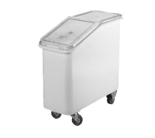 |  |  | 1 ea |  | INGREDIENT BIN  Cambro Model No. IBS20148  Ingredient Bin, mobile, 21 gallon capacity, molded polyethylene with sliding cover, S‐hook on front (scoop NOT included), (4) 3" heavy duty casters (2 front swivel, 2 fixed), with bin securely attached to base plate, white with clear cover, NSF
E247  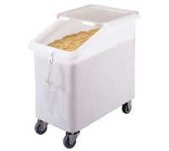 |  |  | 1 ea |  | INGREDIENT BIN  Cambro Model No. IBS27148  Ingredient Bin, mobile, 27 gallon capacity, 1‐pc seamless polyethylene bin, 2‐pc sliding polycarbonate lid, S‐hook on front (scoop NOT included), (4) 3" heavy duty casters (2 front swivel, 2 fixed), white with clear cover, NSF
E2471  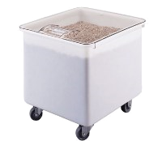 |  |  | 1 ea |  | INGREDIENT BIN  Cambro Model No. IB32148  Ingredient Bin, mobile, 32 gallon capacity, molded polyethylene with sliding cover, (4) 3" heavy duty casters (2 front swivel, 2 fixed), with bin securely attached to base plate, white with clear cover, NSF
E248  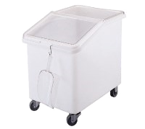 |  |  | 1 ea |  | INGREDIENT BIN  Cambro Model No. IBS37148  Ingredient Bin, mobile, 37 gallon capacity, 1‐pc seamless polyethylene bin, 2‐pc sliding polycarbonate lid, S‐hook on front (scoop NOT included), (4) 3" heavy duty casters (2 front swivel, 2 fixed), white with clear cover, NSF
E249  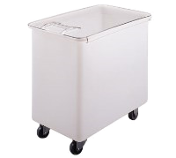 |  |  | 1 ea |  | INGREDIENT BIN  Cambro Model No. IB44148  Ingredient Bin, mobile, 42‐1/2 gallon capacity, molded polyethylene with sliding cover, (4) 3" heavy duty casters (2 front swivel, 2 fixed), with bin securely attached to base plate, white with clear cover, NSF
E003  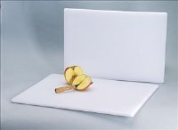 |  |  | 1 ea |  | CUTTING BOARD  ABC Procurement Model No. CBP‐18  Cutting Board, 18" x 24" x 1/2" thick, polyethylene, white, NSF
Item |  | Qty |  |  |  |  | Description |  |  | Price
E104 |  | 1 ea |  |  |  |  | MIXING BOWL, METAL  ABC Procurement Model No. MBR‐13  Mixing Bowl, 13 qt, 16" top dia., flare rim, flat bottom, 0.4 mm thickness, stainless steel
E106  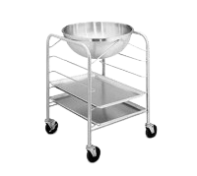 |  | 1 ea |  |  |  |  | MIXING BOWL, METAL  Vollrath Model No. 79300  Mixing Bowl ONLY, 30 quart, 18/8 Stainless, 21 5/8" dia., for 79301 &  79302 30 quart, Mobile Bowl units, NSF, Made in USA
E097 |  | 1 ea |  |  |  |  | MIXING BOWL, METAL  ABC Procurement Model No. MBR‐03  Mixing Bowl, 3 qt, 9‐1/2" top dia., flare rim, flat bottom, 0.4 mm thickness, stainless steel
E100 |  | 1 ea |  |  |  |  | MIXING BOWL, METAL  ABC Procurement Model No. MBR‐05  Mixing Bowl, 5 qt, 11‐3/4" top dia., flare rim, flat bottom, 0.4 mm thickness, stainless steel
E102 |  | 1 ea |  |  |  |  | MIXING BOWL, METAL  ABC Procurement Model No. MBR‐08  Mixing Bowl, 8 qt, 14" top dia., flare rim, flat bottom, 0.4 mm thickness, stainless steel
E251  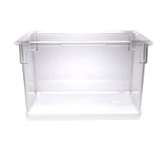 |  | 1 ea |  |  |  |  | FOOD CONTAINER BOX  Cambro Model No. 182615CW135  Camwear® Food Storage Container, 18" x 26" x 15", 22 gallon capacity, dishwasher safe, smooth surface, polycarbonate, clear, NSF  2 year warranty
E252A  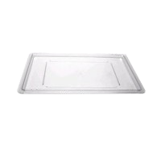 |  | 1 ea |  |  |  |  | FOOD STORAGE CONTAINER COVER  Cambro Model No. 1826CCW135  Camwear® Cover, food storage, flat, 18" x 26", polycarbonate, clear, NSF
E256  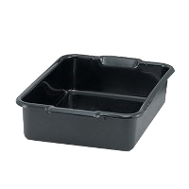 |  | 1 ea |  |  |  |  | BUS BOX / TUB  Vollrath Model No. 1521B‐31  Traex® Deluxe Bus Box, 1‐compartment, 21‐3/4"W x 15‐5/8"D x 5"deep, temperature range: ‐30° to 183°F, reinforced top & bottom, high‐density polyethylene, gray, NSF, Made in USA (must order in bulk quantity of 150)
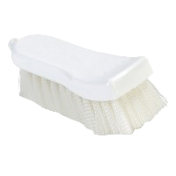  E004 |  | 1 ea |  |  |  |  | CUTTING BOARD BRUSH  Carlisle Model No. 4052000  Sparta® Spectrum® Cutting Board Brush, 6" nylon bristles
Item |  |  |  | Qty |  |  |  | Description |  | Price
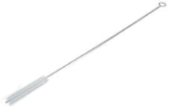 |  |  |  | 1 ea |  |  |  | Carlisle Model No. 4067300  Sparta® Urn Brush, 25" long, 5"L x 5/8" dia. polyester bristles, looped end, compact, straight wire handle, standard color
E0041  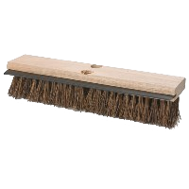 |  |  |  | 1 ea |  |  |  | FLOOR SCRUB BRUSH  Carlisle Model No. 3639500  Flo‐Pac® Floor Scrub Brush, 14" wood block, synthetic palmyra bristles & squeegee (handle NOT included)
E0041A |  |  |  | 1 ea |  |  |  | BROOM, PARTS  Rubbermaid Model No. FG636200NAT  Handle, 60"L, 1‐1/8" dia., wood, tapered, sanded, natural
E0042  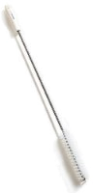 |  |  |  | 1 ea |  |  |  | BRUSH, VALVE & FITTINGS  Carlisle Model No. 4015000  Sparta® Kettle Valve Brush, 28" long, 6"L x 1‐3/8" dia. stiff polyester wire wound bristles, hanging hole, plastic handle, 9 gauge galvanized wire, standard color, BPA‐Free
E258  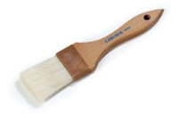 |  |  |  | 1 ea |  |  |  | BRUSH, BASTING  Carlisle Model No. 4037400  Sparta® Chef Series™ Basting Brush, 2" wide epoxy‐set bristles, double‐boiled, water‐resistant, brown plastic ferrules, lacquered hardwood handle, boars hair, bleached
E260  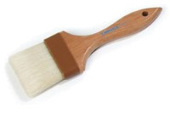 |  |  |  | 1 ea |  |  |  | BRUSH, BASTING  Carlisle Model No. 4037500  Sparta® Chef Series™ Basting Brush, 3" wide epoxy‐set bristles, double‐boiled, water‐resistant, brown plastic ferrules, lacquered hardwood handle, boars hair, bleached
E0051  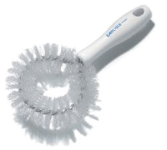 |  |  |  | 1 ea |  |  |  | BRUSH, VEGETABLE  Carlisle Model No. 4016402  Sparta® Vegetable Brush, 9‐1/2" long, circular bristle/wire head with straight handle, firm bristles, polyester, white
E0043  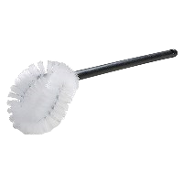 |  |  |  | 1 ea |  |  |  | BRUSH, TOILET BOWL  Carlisle Model No. 36P502  Flo‐Pac® Bowl Brush, 17" long, 5"L x 4‐1/2"W brush head, non-scratching, twist‐in‐wire bristles, hanging hole, handle, polypropylene, white
E266  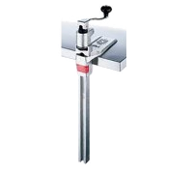 |  |  |  | 1 ea |  |  |  | CAN OPENER  Edlund Model No. 1  Can Opener, manual, #1™ with plated base (for cans up to 11" tall), "Old Reliable"™  1 year limited warranty, standard
Item |  |  |  | Qty |  |  |  | Description |  | Price
E270 |  | 1 ea |  |  |  |  | CAN OPENER PARTS  Edlund Model No. G003SP  Gear, #1™, single pack (must purchase in multiples of 50)
E268 |  | 1 ea |  |  |  |  | CAN OPENER PARTS  Edlund Model No. K004SP  #1™ Knife, single pack (must purchase in multiples of 50)
E018  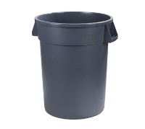 |  | 1 ea |  |  |  |  | COMMERCIAL WASTE CONTAINER  Carlisle Model No. 34103223  Bronco™ Waste Container, 32 gallon, 27‐3/4"H x 22‐3/8" dia. (25‐1/2" dia. with handles), round, double‐reinforced stress ribs, ergonomic Comfort Curve™ handles, drag skids, deep hand holds on base, polyethylene, gray, NSF
E008A  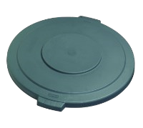 |  | 1 ea |  |  |  |  | TRASH RECEPTACLE LID / TOP  Carlisle Model No. 34103323  Bronco™ Waste Container Lid, round, 2‐1/8"H x 22.5" dia. (25‐1/2" dia. with handles), heavy‐duty, snap down tab locks, for 32 gallon container, polyethylene, gray, NSF
E009  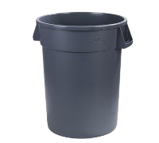 |  | 1 ea |  |  |  |  | COMMERCIAL WASTE CONTAINER  Carlisle Model No. 34104423  Bronco™ Waste Container, 44 gallon, 31‐3/8"H x 24‐1/2" dia. (27‐1/2" dia. with handles), round, double‐reinforced stress ribs, ergonomic Comfort Curve™ handles, drag skids, deep hand holds on base, polyethylene, gray, NSF
E009A  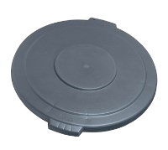 |  | 1 ea |  |  |  |  | TRASH RECEPTACLE LID / TOP  Carlisle Model No. 34104523  Bronco™ Waste Container Lid, round, 2‐1/4"H x 26‐7/8" dia., heavyduty, snap down tab locks, for 44 gallon container, polyethylene, gray, NSF
E010  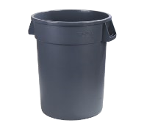 |  | 1 ea |  |  |  |  | COMMERCIAL WASTE CONTAINER  Carlisle Model No. 34105523  Bronco™ Waste Container, 55 gallon, 33"H x 26‐1/2" dia. (31‐1/2" dia.  with handles), round, double‐reinforced stress ribs, ergonomic Comfort Curve™ handles, drag skids, deep hand holds on base, polyethylene, gray, NSF
E010A  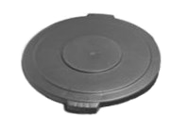 |  | 1 ea |  |  |  |  | TRASH RECEPTACLE LID / TOP  Carlisle Model No. 34105623  Bronco™ Waste Container Lid, round, 2‐1/4"H x 29‐9/11" dia., heavy duty, snap down tab locks, for 55 gallon container, polyethylene, gray, NSF
Item | Qty |  |  |  |  | Description |  |  |  |  | Price
E016  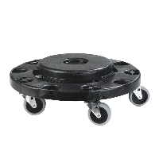 | 1 ea |  |  |  |  | TRASH RECEPTACLE, DOLLY  Carlisle Model No. 3691103  Bronco™ Container Dolly, round, 6"H x 17‐3/4" dia., twist‐to‐lock, nonmarking 3" swivel press‐fit casters, fits 20, 32, 44 & 55 gal containers, polyethylene, black, NSF
E457  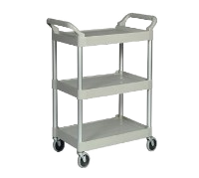 | 1 ea |  |  |  |  | UTILITY CART  Rubbermaid Model No. FG342488PLAT  Utility Cart, 33‐5/8"L x 18‐5/8"W x 37‐3/4"H, 200 lb. capacity, (3) shelves, smooth surface, handles, open sides, plastic construction, brushed aluminum uprights, (4) 4" swivel casters, assembly required, platinum, HACCP, S.O.S. (Special Order Smallwares) product; see SOS document for details
E276  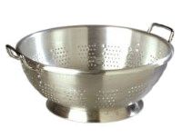 | 1 ea |  |  |  |  | COLANDER  Carlisle Model No. 60279  Colander, 11 qt., 15" dia. x 5‐3/4" deep, rolled top edge, seamless, footed, riveted loop handles, dishwasher safe, standard‐weight, aluminum, satin finish
E278  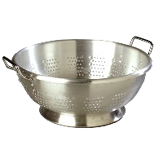 | 1 ea |  |  |  |  | COLANDER  Carlisle Model No. 60280  Colander, 16 qt., 16‐1/2" dia. x 7‐1/8" deep, rolled top edge, seamless, footed, riveted loop handles, dishwasher safe, standard‐weight, aluminum, satin finish
E108  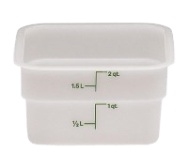 | 1 ea |  |  |  |  | SQUARE FOOD CONTAINER  Cambro Model No. 2SFSP148  CamSquare® Food Container, 2 qt., 7‐1/4"L x 7‐1/4"W x 3‐7/8"H, green graduation, polyethylene, dishwasher safe, resists stains & odors, natural white, NSF
E110  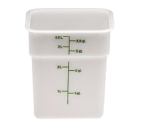 | 1 ea |  |  |  |  | SQUARE FOOD CONTAINER  Cambro Model No. 4SFSP148  CamSquare® Food Container, 4 qt., 7‐1/4"L x 7‐1/4"W x 7‐3/8"H, green graduation, polyethylene, dishwasher safe, resists stains & odors, natural white, NSF
E111  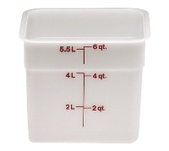 | 1 ea |  |  |  |  | SQUARE FOOD CONTAINER  Cambro Model No. 6SFSP148  CamSquare® Food Container, 6 qt., 8‐3/8"L x 8‐3/8"W x 7‐1/4"H, red graduation, polyethylene, dishwasher safe, resists stains & odors, natural white, NSF
E1112  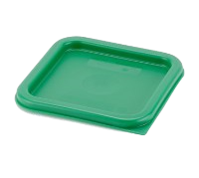 | 1 ea |  |  |  |  | FOOD STORAGE CONTAINER COVER  Cambro Model No. SFC2452  Cover, for 2 & 4 qt. containers, polyethylene, Kelly green, NSF

Item | Qty | Description | Price
E11121  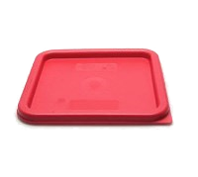 | 1 ea | FOOD STORAGE CONTAINER COVER  Cambro Model No. SFC6451  Cover, for 6 & 8 qt. containers, polyethylene, winter rose, NSF
E441  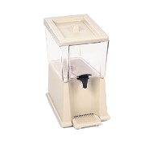 | 1 ea | BEVERAGE DISPENSER, NON‐INSULATED  Rubbermaid Model No. FG335800CLR  Beverage Dispenser, 3 gallon, 16‐3/4"W x 10‐3/8"D x 18‐7/8"H, includes: tank, base, drain tray, lid & labels, interchangeable polycarbonate tank, clear, NSF, S.O.S. (Special Order Smallwares) product; see SOS document for details
E280  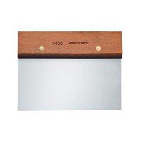 | 1 ea | DOUGH CUTTER/SCRAPER  Dexter Russell Model No. S496PCP  Traditional™ (19790) Dough Cutter/Scraper, 6" x 3", stainless steel blade, rosewood handle, Perfect Cutlery Packaging
E286  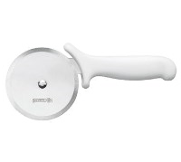 | 1 ea | PIZZA CUTTER  Mundial Model No. W5691‐4  Pizza Cutter, 4" wheel, stainless steel blade, molded white  polypropylene handle, treated with sanitized antimicrobial protection (hang tag)
E442  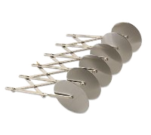 | 1 ea | PASTRY DOUGH CUTTING WHEEL  Alegacy Foodservice Products Model No. 2225  Dough Cutter, 19‐3/4"L O.A.L, (5) 2‐1/8" dia. wheels, nickel‐plated Steel
E443  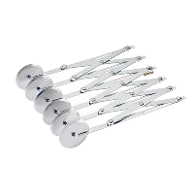 | 1 ea | PASTRY DOUGH CUTTING WHEEL  Browne USA Foodservice Model No. 2226  Dough Cutter, 2‐1/8" dia. stainless steel wheels, adjustable to 24‐1/8" (fully open), nickel‐plated steel frame
E122  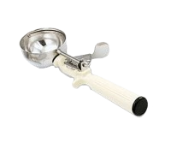 | 1 ea | STANDARD ROUND BOWL DISHER  Vollrath Model No. 47141  Disher, round bowl, size 10 (3‐1/4 oz. capacity), 2‐5/8" bowl dia., 18‐8 stainless with one‐piece color coded ivory plastic handle with all natural antimicrobial NSF, Made in USA, Jacob's Pride® Collection, Limited Lifetime Warranty

Item | Qty | Description | Price
E128  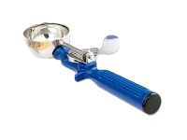 | 1 ea | STANDARD ROUND BOWL DISHER  Vollrath Model No. 47143  Disher, round bowl, size 16 (2 oz. capacity), 2‐3/16" bowl dia., 18‐8 stainless with one‐piece color coded dark blue plastic handle with all natural antimicrobial NSF, Made in USA, Jacob's Pride® Collection, Limited Lifetime Warranty
E130  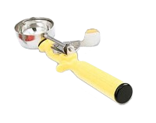 | 1 ea | STANDARD ROUND BOWL DISHER  Vollrath Model No. 47144  Disher, round bowl, size 20 (1‐5/8 oz. capacity), 2" bowl dia., 18‐8 stainless with one‐piece color coded yellow plastic handle with all natural antimicrobial NSF, Made in USA, Jacob's Pride® Collection, Limited Lifetime Warranty
E132  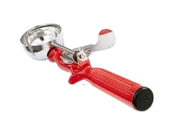 | 1 ea | STANDARD ROUND BOWL DISHER  Vollrath Model No. 47145  Disher, round bowl, size 24 (1‐1/3 oz. capacity), 1‐7/8" bowl dia., 18‐8 stainless with one‐piece color coded red plastic handle with all natural antimicrobial NSF, Made in USA, Jacob's Pride® Collection, Limited Lifetime Warranty
E134  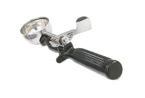 | 1 ea | STANDARD ROUND BOWL DISHER  Vollrath Model No. 47146  Disher, round bowl, size 30 (1 oz. capacity), 1‐3/4" bowl dia., 18‐8 stainless with one‐piece color coded black plastic handle with all natural antimicrobial NSF, Made in USA, Jacob's Pride® Collection, Limited Lifetime Warranty
E136  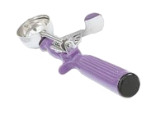 | 1 ea | STANDARD ROUND BOWL DISHER  Vollrath Model No. 47147  Disher, round bowl, size 40 (3/4 oz. capacity), 1‐9/6" bowl dia., 18‐8 stainless with one‐piece color coded orchid plastic handle with all natural antimicrobial NSF, Made in USA, Jacob's Pride® Collection, Limited Lifetime Warranty
E118  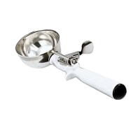 | 1 ea | STANDARD ROUND BOWL DISHER  Vollrath Model No. 47139  Disher, round bowl, size 6 (5‐1/3 oz. capacity), 3‐1/8" bowl dia., 18‐8 stainless with one‐piece color coded white plastic handle with all natural antimicrobial NSF, Made in USA, Jacob's Pride® Collection, Limited Lifetime Warranty
E120  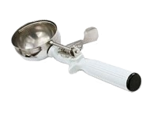 | 1 ea | STANDARD ROUND BOWL DISHER  Vollrath Model No. 47140  Disher, round bowl, size 8 (4 oz. capacity), 2‐13/16" bowl dia., 18‐8 stainless with one‐piece color coded grey plastic handle with all natural antimicrobial NSF, Made in USA, Jacob's Pride® Collection, Limited Lifetime Warranty
E047  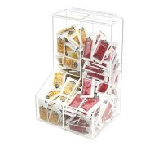 | 1 ea | CONDIMENT DISPENSER  Cal‐Mil Model No. 925  Classic Packet Dispenser, 2 bin, 8‐1/2" x 4" x 12"H, acrylic, clear

Item | Qty | Description | Price
E048 | 1 ea | TEA DISPENSER  Bloomfield Ind. Model No. 8699‐3G‐SG  Iced Tea Dispenser, 3‐gallon capacity, 19‐3/8" H, 9" W x 13‐1/2" D, round7" to 8" clearance no‐drip removable faucet, brew‐through plastic lid, with handles, with sight glass, stainless steel construction, portable design, NSF
 | 1 ea | 1 year parts & labor warranty, standard
E018  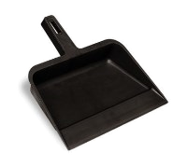 | 1 dz | DUST PAN  Continental Commercial Products Model No. 712  Dust Pan, 4" x 12‐1/4" x 12", industrial plastic, black
E020 | 1 ea | LOBBY DUST PAN  Carlisle Model No. 36141003  Flo‐Pac® Duo‐Pan™ Lobby Dust Pan, 12" wide, hanging hole, pivot and lock bucket, metal handle, plastic, black
E137  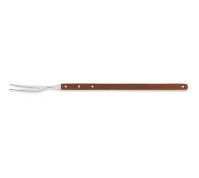 | 1 ea | COOK'S FORK  Mundial Model No. 4654‐22  Broiler Fork, 22", curved tines, stainless steel, extra long wood handle (pouch)
E1371  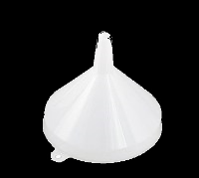 | 1 ea | FUNNEL  Browne USA Foodservice Model No. 369  Funnel, 16 oz., 5‐1/4" dia., one‐piece, seamless, polyethylene
E402  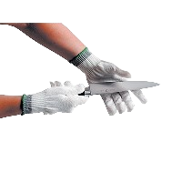 | 1 ea | CUT RESISTANT GLOVE  San Jamar Model No. SG10‐S  Dyneema® Glove, small, fits either hand, cut resistant, contains Double Guard™ anti‐microbial agent, Dyneema® with optical glass core, meets OSHA standard, ANSI Level 5 cut protection, white
E402‐  M  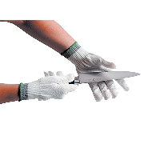 | 1 ea | CUT RESISTANT GLOVE  San Jamar Model No. SG10‐M  Dyneema® Glove, medium, fits either hand, cut resistant, contains Double Guard™ anti‐microbial agent, Dyneema® with optical glass core, meets OSHA standard, ANSI Level 5 cut protection, white

Item | Qty | Description | Price
E402‐L  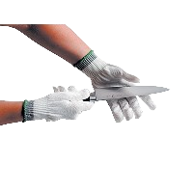 | 1 ea | CUT RESISTANT GLOVE  San Jamar Model No. SG10‐L  Dyneema® Glove, large, fits either hand, cut resistant, contains Double Guard™ anti‐microbial agent, Dyneema® with optical glass core, meets OSHA standard, ANSI Level 5 cut protection, white
E402XL  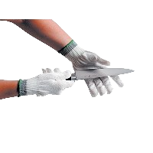 | 1 ea | CUT RESISTANT GLOVE  San Jamar Model No. SG10‐XL  Dyneema® Glove, X‐large, fits either hand, cut resistant contains Double Guard™ anti‐microbial agent, Dyneema® with optical glass core, meets OSHA standard, ANSI Level 5 cut protection, white
E400  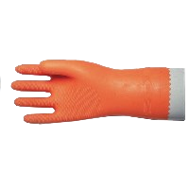 | 1 dz | GLOVES  San Jamar Model No. 720‐L  Dishwashing Glove, large, 13", embossed grip, heat resistant, 28 mil neoprene & latex blend with flock lining, orange, USDA accepted (priced per dozen pairs)
E296  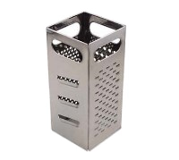 | 1 ea | GRATER, MANUAL  Browne USA Foodservice Model No. SSG449  Grater, 4" x 4" x 9"H, (4) surfaces: coarse shredder, medium shredder, slicer & julienne cut, stainless steel
E422  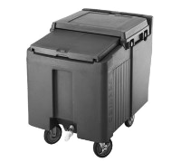 | 1 ea | ICE BIN / ICE CADDY , MOBILE  Cambro Model No. ICS125L110  SlidingLid™ Ice Caddy, mobile, 29‐1/4"H, 125 lb. capacity, lid slides back & under, polyethylene body with foam insulation, molded in handles, recessed front drain faucet, no assembly required, (4) 5" casters (2 fixed, 2 swivel, 1 with brake), black, NSF
E456  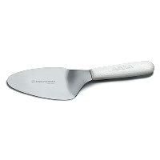 | 1 ea | PIE KNIFE  Dexter Russell Model No. S175PCP  Sani‐Safe® (19763) Pie Knife, 5", stainless steel, offset blade, textured, polypropylene white handle, Perfect Cutlery Packaging, NSF Certified, Made in USA
E298  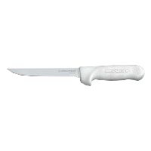 | 1 ea | BONING KNIFE  Dexter Russell Model No. S136F‐PCP  Sani‐Safe® (01543) Boning Knife, 6", flexible, stain‐free, high‐carbon steel, textured, polypropylene white handle, Perfect Cutlery  Packaging, NSF Certified, Made in USA

Item | Qty | Description | Price
E308  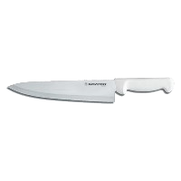 | 1 ea | CHEF KNIFE  Dexter Russell Model No. P94802  Basics® (31601) Chef's/Cook's Knife, 10", stain‐free, high‐carbon steel,  textured, polypropylene white handle, NSF Certified
E310  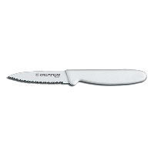 | 1 ea | PARING KNIFE  Dexter Russell Model No. P94846  Basics® (31612) Paring Knife, 3‐1/8", scalloped, edge, tapered point, stain‐free, high‐carbon steel, polypropylene white handle, NSF Certified
E311  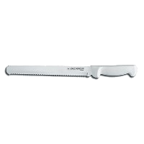 | 1 ea | BREAD / SANDWICH KNIFE  Dexter Russell Model No. P94804  Basics® (31604) Slicer/ Bread Knife, 10", scalloped edge, stain‐free, high‐carbon steel, textured, polypropylene white handle, NSF Certified
E312  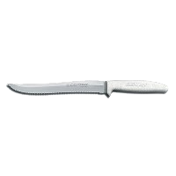 | 1 ea | UTILITY KNIFE  Dexter Russell Model No. S158SC‐PCP  Sani‐Safe® (13483) Utility Slicer, 8", scalloped edge, stain‐free, high carbon steel, textured, polypropylene white handle, Perfect Cutlery Packaging, NSF Certified, Made in USA
E154A  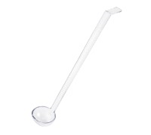 | 1 ea | SALAD BAR LADLE  Winco Model No. PLD‐13C  Ladle, 1 oz., 13" long, one‐piece, polycarbonate, clear, NSF (12 each per inner case, 192 each per master case)
E145  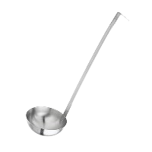 | 1 ea | SERVING LADLE  Browne USA Foodservice Model No. 274112  Conventional Ladle, 1‐1/2 ounce, 9"L, two‐piece, hooked handle, 2.0 mm thickness, heavy gauge, satin finish
E152  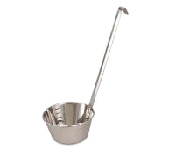 | 1 ea | DIPPER  Browne USA Foodservice Model No. 72919  Dipper, 32 oz., 12‐1/2"L, solder seal, 0.6 mm thickness, stainless steel
E154  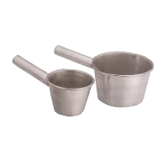 | 1 ea | DIPPER  Vollrath Model No. 5332  Transfer Ladle/Dipper, 64 oz., 13‐5/8"L, 3004 aluminum alloy

Item | Qty | Description | Price
E146  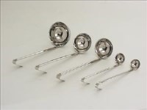 | 1 ea | SERVING LADLE  ABC Procurement Model No. LL‐02‐P  Ladle, 2 oz., bowl capacity stamped on 10‐3/4" handle, one‐piece, stainless steel, NSF
E148 | 1 ea | SERVING LADLE  ABC Procurement Model No. LL‐04‐P  Ladle, 4 oz., bowl capacity stamped on 12‐1/2" handle, one‐piece, stainless steel, NSF
E149 | 1 ea | SERVING LADLE  ABC Procurement Model No. LL‐06‐P  Ladle, 6 oz., bowl capacity stamped on 12‐1/2" handle, one‐piece, stainless steel, NSF
E150 | 1 ea | SERVING LADLE  ABC Procurement Model No. LL‐08‐P  Ladle, 8 oz., bowl capacity stamped on 12‐9/16" handle, one‐piece, stainless steel, NSF
E455 | 1 ea | FLOOR MAT, CARPET  Apex Matting & Foodservice Products Model No. 436‐971  GRAY 3'X5' GREASE PROOF MAT BEVELED EDGE WITH HOLES, GRAY ONLY
E112  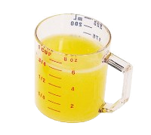 | 1 ea | MEASURING CUP  Cambro Model No. 25MCCW135  Camwear® Measuring Cup, 1 cup, dry measure, molded handle,  dishwasher safe, polycarbonate, clear, NSF
E114  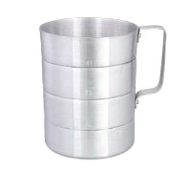 | 1 ea | MEASURING CUP  Browne USA Foodservice Model No. M40  Dry Measure, 4 qt., 7‐3/8" x 8‐1/2", capacity markings, large riveted handles, seamless construction, 1.8 mm thickness, heavy‐duty aluminum
E200  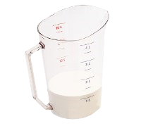 | 1 ea | MEASURING CUP  Cambro Model No. 400MCCW135  Camwear® Measuring Cup, 4 qt., molded handle, dishwasher safe, polycarbonate, clear, NSF
E196  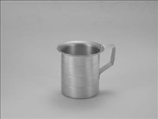 | 1 ea | MEASURING CUP  ABC Procurement Model No. GM‐1‐A  Measuring Cup, 1 qt., with pouring lip, graduation markings on side, aluminum

Item | Qty | Description | Price
E198  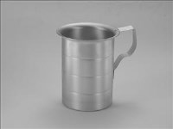 | 1 ea | MEASURING CUP  ABC Procurement Model No. GM‐2‐A  Measuring Cup, 2 qt., with pouring lip, graduation markings on side, aluminum
E194  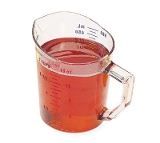 | 1 ea | MEASURING CUP  Cambro Model No. 50MCCW135  Camwear® Measuring Cup, 1 pint, molded handle, dishwasher safe, polycarbonate, clear, NSF
E313  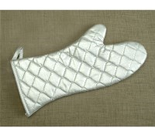 | 1 pr | OVEN MITT  John Ritzenthaler Company Model No. CLOMS26SL  Ritz® Chef's Line® Oven/Freezer Mitt, elbow length, 16", protects up to 350°, non‐stick silicone, pair, silver,(retail packaging), (must order full case of 12 pairs)
E034A  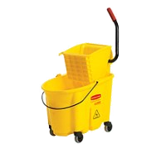 | 1 ea | MOP BUCKET WRINGER COMBINATION  Rubbermaid Model No. FG758088YEL  WaveBrake® Mopping Combo Pack, 7570 mop bucket; 6127‐01 wringer, non‐marking casters, yellow
E454B  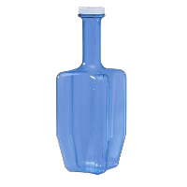 | 1 ea | CHILLING PADDLE  San Jamar Model No. RCU64  Rapi‐Kool® Cold Paddle, 64 oz., 4‐3/4" dia. x 13‐1/2"H, polycarbonate, NSF
E454C  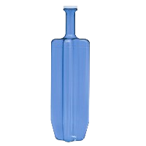 | 1 ea | CHILLING PADDLE  San Jamar Model No. RCU128  Rapi‐Kool® Cold Paddle, 128 oz., 4‐1/2" dia. x 21"H, polycarbonate, NSF
E454  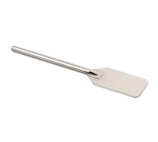 | 1 ea | MIXING PADDLE  Browne USA Foodservice Model No. 19936  Mixing Paddle, 4‐1/2" x 8" paddle, 36" O.A.L., stainless steel, polished finish
E155  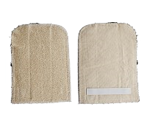 | 1 ea | PAN GRABBER  Winco Model No. PH‐811W  Pan Grabber, 8" x 11", rectangular, heat resistant up to 400°F, terry cloth

Item | Qty | Description | Price
E193A  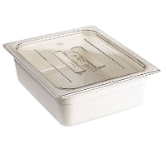 | 1 ea | FOOD PAN COVER  Cambro Model No. 60CWCH135  Camwear® Food Pan Cover, 1/6 size, with handle, polycarbonate, clear, NSF
E193  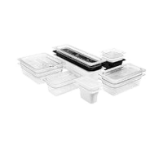 | 1 ea | PLASTIC FOOD PAN  Cambro Model No. 24CW135  Camwear® Food Pan, 6.3 qt. capacity, 4" deep, 1/2 size, polycarbonate, clear, NSF
 |  | 2 year warranty
E163  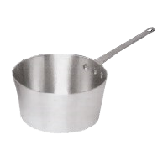 | 1 ea | SAUCE PAN  Vollrath Model No. 7341  Arkadia™ Sauce Pan, 1‐1/2 quart, riveted handle, 3000 series aluminum, natural finish
E174 | 1 ea | SAUCE PAN  Vollrath Model No. 7350  Arkadia™ Sauce Pan, 10 quart, 11‐3/4 inside diameter, inside depth 53/4", riveted handle, 9 gage 3000 series aluminum, natural finish, includes assist loop handle, NSF
E164 | 1 ea | SAUCE PAN  Vollrath Model No. 7343  Arkadia™ Sauce Pan, 3‐3/4 quart, riveted handle, 3000 series aluminum, natural finish
E166 | 1 ea | SAUCE PAN  Vollrath Model No. 7344  Arkadia™ Sauce Pan, 4‐1/2 quart, riveted handle, 3000 series aluminum, natural finish
E168 | 1 ea | SAUCE PAN  Vollrath Model No. 7345  Arkadia™ Sauce Pan, 5‐1/2 quart, riveted handle, 3000 series aluminum, natural finish
E170 | 1 ea | SAUCE PAN  Vollrath Model No. 7347  Arkadia™ Sauce Pan, 7 quart, riveted handle, 3000 series aluminum, natural finish

Item | Qty | Description | Price
E172 | 1 ea | SAUCE PAN  Vollrath Model No. 7348  Arkadia™ Sauce Pan, 8‐1/2 quart, riveted handle, 3000 series aluminum, natural finish
E176 | 1 ea | BUN PAN  ABC Procurement Model No. 5323  Sheet Pan, half size, 18" x 13" x 1", 19 gauge aluminum, NSF
E178 | 1 ea | BUN PAN  ABC Procurement Model No. 5326  Sheet Pan, full size, 18" x 26" x 1", 19 gauge aluminum, NSF
E1781  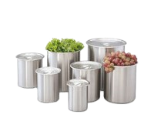 | 1 ea | BAIN MARIE POT  Vollrath Model No. 78780  Bain Marie, 8‐1/4 quart, 8" dia., 9‐3/4" deep, fits 8‐1/2" dia. opening, satin finish stainless steel, NSF, Made in USA
E1843  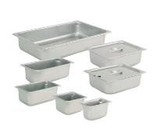 | 1 ea | STEAM TABLE PAN COVER, STAINLESS STEEL  ABC Procurement Model No. 75139  Steam Table Pan Cover, 1/3 size, flat, solid, recessed handle, 22 gauge 18/8 stainless steel, NSF
E186 | 1 ea | FOOD PAN, STAINLESS STEEL  ABC Procurement Model No. 88002931  Food Pan, full, 2‐1/2" deep, 25 gauge stainless steel
E182  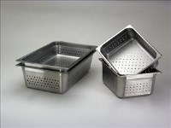 | 1 ea | STEAM TABLE PAN, STAINLESS STEEL  ABC Procurement Model No. CAST‐1204‐PF  Steam Table Pan, 1/2 size, 4" deep, perforated, 24 gauge 18/8 stainless steel, NSF
E1821  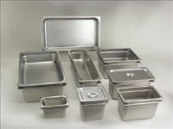 | 1 ea | STEAM TABLE PAN, STAINLESS STEEL  ABC Procurement Model No. CAST‐1202  Steam Table Pan, 1/2 size, 2‐1/2" deep, 24 gauge 18/8 stainless steel,  NSF
E1822 | 1 ea | STEAM TABLE PAN, STAINLESS STEEL  ABC Procurement Model No. CAST‐1204  Steam Table Pan, 1/2 size, 4" deep, 24 gauge 18/8 stainless steel, NSF
E184 | 1 ea | FOOD PAN, STAINLESS STEEL  ABC Procurement Model No. 880223  Food Pan, half, 2‐1/2" deep, perforated, 25 gauge stainless steel

Item | Qty | Description | Price
E184A | 1 ea | STEAM TABLE PAN, STAINLESS STEEL  ABC Procurement Model No. 222056931  Steam Table Pan, 1/2 size long, 6" deep, 22 gauge 18/8 stainless steel,  NSF
E1841 | 1 ea | FOOD PAN, STAINLESS STEEL  ABC Procurement Model No. 88032931  Food Pan, 1/3 GN, 2‐1/2" deep, 25 gauge stainless steel
E1842 | 1 ea | STEAM TABLE PAN, STAINLESS STEEL  ABC Procurement Model No. CAST‐1304  Steam Table Pan, 1/3 size, 4" deep, 24 gauge 18/8 stainless steel, NSF
E1842A | 1 ea | FOOD PAN, STAINLESS STEEL  ABC Procurement Model No. 88036931  Food Pan, 1/3 GN, 6" deep, 25 gauge stainless steel
E1822A  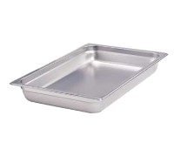 | 1 ea | STEAM TABLE PAN, STAINLESS STEEL  Crestware Model No. 2224  Steam Table/Holding Pan, 1/2 size long, 4" deep, Saf‐T‐Rim, jam reduction shoulder, 18/8 stainless steel, 22 gauge, NSF, Saf‐T‐Stak
E1852 | 1 ea | STEAM TABLE PAN, STAINLESS STEEL  ABC Procurement Model No. CAST‐1404  Steam Table Pan, 1/4 size, 4" deep, 24 gauge 18/8 stainless steel, NSF
E191 | 1 ea | STEAM TABLE PAN COVER, STAINLESS STEEL  ABC Procurement Model No. 77259  Steam Table Pan Cover, full size, flat, solid, recessed handle, 22 gauge 18/8 stainless steel, NSF
E1844  A  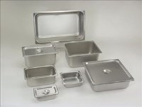 | 1 ea | STEAM TABLE PAN COVER, STAINLESS STEEL  ABC Procurement Model No. CSTC‐1400  Steam Table Pan Cover, 1/4 size flat, solid, recessed handle, 24 gauge 18/8 stainless steel, NSF
E180 | 1 ea | STEAM TABLE PAN, STAINLESS STEEL  ABC Procurement Model No. CAST‐2002‐PF  Steam Table Pan, full size, 2‐1/2" deep, perforated, 24 gauge 18/8 stainless steel, NSF

Item | Qty | Description | Price
E181 | 1 ea | STEAM TABLE PAN, STAINLESS STEEL  ABC Procurement Model No. CAST‐2004‐PF  Steam Table Pan, full size, 4" deep, perforated, 24 gauge 18/8 stainless steel, NSF
E1861  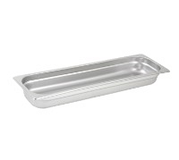 | 1 ea | STEAM TABLE PAN, STAINLESS STEEL  Winco Model No. SPJL‐2HL  Steam Table Pan, 1/2 size long, 2‐1/2" deep, 25 gauge standard weight, anti‐jamming, stainless steel, NSF (6 each per inner case, 24 each per master case)
E190 | 1 ea | STEAM TABLE PAN, STAINLESS STEEL  ABC Procurement Model No. CAST‐2006  Steam Table Pan, full size, 6" deep, 24 gauge 18/8 stainless steel, NSF
E1821A | 1 ea | STEAM TABLE PAN, STAINLESS STEEL  ABC Procurement Model No. CAST‐1202  Steam Table Pan, 1/2 size, 2‐1/2" deep, 24 gauge 18/8 stainless steel,  NSF
E188 | 1 ea | FOOD PAN, STAINLESS STEEL  ABC Procurement Model No. 88004931  Food Pan, full, 4" deep, 25 gauge stainless steel
E1851 | 1 ea | FOOD PAN, STAINLESS STEEL  ABC Procurement Model No. 88046931  Food Pan, 1/4 GN, 6" deep, 25 gauge stainless steel
E1852A | 1 ea | STEAM TABLE PAN COVER, STAINLESS STEEL  ABC Procurement Model No. CSTC‐1400  Steam Table Pan Cover, 1/4 size flat, solid, recessed handle, 24 gauge 18/8 stainless steel, NSF
E185 | 1 ea | STEAM TABLE PAN COVER, STAINLESS STEEL  ABC Procurement Model No. CSTC‐1200  Steam Table Pan Cover, 1/2 size flat, solid, recessed handle, 24 gauge 18/8 stainless steel, NSF
E184B  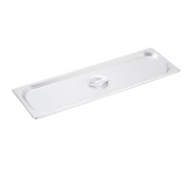 | 1 ea | STEAM TABLE PAN COVER, STAINLESS STEEL  Winco Model No. SPJL‐HCS  Steam Table Pan Cover, half long size, solid, 25 gauge standard weight, stainless steel, NSF (12 each per inner case, 24 each per master case)
E1911  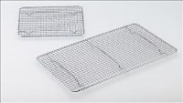 | 1 ea | WIRE PAN GRATE  ABC Procurement Model No. PG‐10  Pan Grate, 10" X 18", chrome plated steel wire construction
Item | Qty | Description | Price
E1912 | 1 ea | PLASTIC FOOD PAN  Cambro Model No. 18CW135  Camwear® Food Pan, 27 qt. capacity, 8" deep, full size, polycarbonate, clear, NSF  2 year warranty
E1912A | 1 ea | FOOD PAN COVER  Cambro Model No. 10CWCH135  Camwear® Food Pan Cover, full size, with handle, polycarbonate, clear, NSF
E324  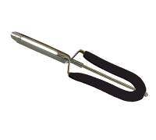 | 1 ea | VEGETABLE PEELER  Focus Foodservice Model No. 327BK  Swing‐A‐Way® Peeler, 8"L, silicone coated handle, stainless steel, black (sold in case packs only)
E056  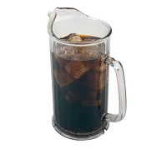 | 1 ea | PLASTIC PITCHER  Cambro Model No. P60CW135  Camwear® Pitcher, 60 oz., 7‐1/4" dia. x 9"H, chip & break resistant, thumb‐grip pour, contoured lip & pour spout, dishwasher safe, slotted base, polycarbonate, clear, NSF
E445  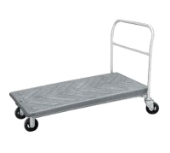 | 1 ea | PLATFORM TRUCK  Winholt Equipment Model No. PN3060  Nesting Cart, single platform, shelf size approximately 30" x 60", reinforced honeycomb plastic shelf, removable crossbar handle, safety bumper, w/four 6" x 2" mold‐on rubber swivel wheels
E326 | 1 ea | POTATO MASHER  Browne USA Foodservice Model No. 1623  Masher, 23"L, 5" x 5" face, one‐piece base, welded base rods, wood handle, nickel‐plated
E431  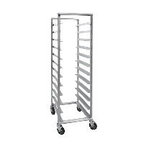 | 1 ea | PAN RACK, BUN  Cres Cor Model No. 207‐1812  Utility Rack, mobile, angle ledge, full height, open sides, riveted pan slides with extruded angles, 5‐1/8" centers, (24) 14" x 18" tray or (12) 18" x 26" pan capacity, end loading, fully welded Hi‐Tensile aluminum frame construction, (4) 5" swivel casters (2) braked, NSF
 |  | Standard Warranty: 3 yr parts, 1‐year labor warranty, lifetime guarantee against rust & corrosion

Item | Qty | Description | Price
E4322  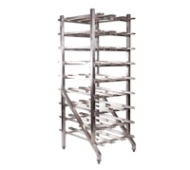 | 1 ea | CAN RACK  Winholt Equipment Model No. CR‐162  Rack, Can Storage, stationary design, self-feeding gravity fed shelves, holds (162) #10 cans or (216) #5 cans, 1‐1/2" welded aluminum tubing, 25 1/4"W, 35"D, 71"H, NSF
E426  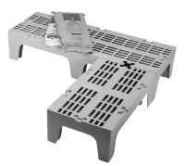 | 1 ea | DUNNAGE RACK  Cambro Model No. DRS300480  S‐Series Dunnage Rack, slotted top, 1500 lb. load capacity, 21"D x 30"W x 12"H, polypropylene, one‐piece, seamless double wall construction, includes (1) Camlink®, 4" square legs, speckled gray, NSF
E427  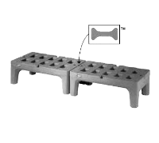 | 1 ea | DUNNAGE RACK  Metro Model No. HP2230PD  Metro Bow‐Tie™ Dunnage Rack, 22" x 30" x 12"H, slotted, with separate polymer tie for joining racks, corrosion proof polymer construction, NSF
E429  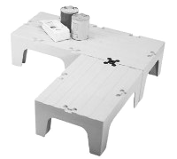 | 1 ea | DUNNAGE RACK  Cambro Model No. DRS30131  S‐Series Dunnage Rack, solid top, 1500 lb. load capacity, 21"D x 30"W x 12"H, polypropylene, one‐piece, seamless double wall construction, includes (1) Camlink®, 4" square legs, dark brown, NSF
E4291 | 1 ea | DUNNAGE RACK  Cambro Model No. DRS36131  S‐Series Dunnage Rack, solid top, 1500 lb. load capacity, 21"D x 36"W x 12"H, polypropylene, one‐piece, seamless double wall construction, includes (1) Camlink®, 4" square legs, dark brown, NSF
E4292 | 1 ea | DUNNAGE RACK  Cambro Model No. DRS48131  S‐Series Dunnage Rack, solid top, 3000 lb. load capacity, 21"D x 48"W x 12"H, polypropylene, one‐piece, seamless double wall construction, includes (1) Camlink®, 4" square legs, dark brown, NSF
E428  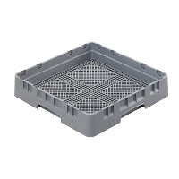 | 1 ea | FLATWARE DISHWASHER RACK  Cambro Model No. FR258151  Camrack® Flatware Rack, full size, 19‐3/4" x 19‐3/4" x 4", 2‐5/8" max. height, soft gray, NSF
E430  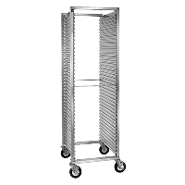 | 1 ea | PAN RACK, BUN  Cres Cor Model No. 200‐1841A  Utility Rack, mobile, full height, closed corrugated sides for 18" x 26" pans, 39 pan capacity, 1‐1/2" centers, end loading, welded Hi‐Tensile aluminum frame construction, (4) 5" swivel casters (2) braked, NSF Standard Warranty: 3 yr parts, 1‐year labor warranty, lifetime guarantee against rust & corrosion
Item | Qty | Description | Price
E432  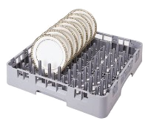 | 1 ea | DISHWASHER RACK, PEG / COMBINATION  Cambro Model No. PR314151  Camrack® 9 x 9 Peg Rack, full size, 19‐3/4" x 19‐3/4" x 4", compartment inches 18" x 18", 3‐1/4" max. height, soft gray, NSF
E446  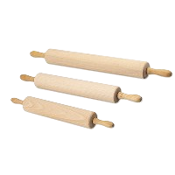 | 1 ea | ROLLING PIN  Browne USA Foodservice Model No. 1313  Rolling Pin, 13"L barrel, 3‐1/2"L handle, 2‐3/4" revolving barrel, stainless steel ball bearing, hardwood
E338  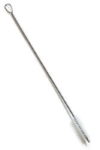 | 1 ea | BRUSH, VALVE & FITTINGS  Carlisle Model No. 4002800  Sparta® Dishwasher Spray Arm Brush, 35" long, 5"L x 1" dia. polyester bristles, looped end, twisted wire handle, standard color, BPA‐Free
E059  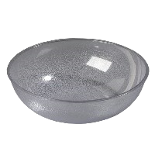 | 1 ea | PLASTIC SERVING BOWL  Carlisle Model No. 721807  Salad Bowl, 18 qt., 18" dia., round, pebbled exterior, scratch and stain resistant, freezer/dishwasher safe, polycarbonate, clear, NSF
E339  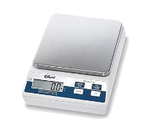 | 1 ea | PORTION SCALE  Edlund Model No. E‐160  Scale, Digital Portion, top loading counter model, digital display, battery or A/C, 160 oz x .1 oz (5000 gm x 1 gm), plastic body & stainless steel platform, automatic push button tare, NSF certified
 |  | 1 year limited warranty, standard
E340  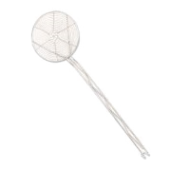 | 1 ea | SKIMMER  Browne USA Foodservice Model No. 1309  Skimmer, 9" dia., 17‐1/2"L, hooked handle, coarse mesh, spiral wire, nickel‐plated
E448  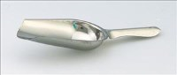 | 1 ea | SCOOP  ABC Procurement Model No. ISC‐5  Ice Scoop, 4 oz., 9‐1/2" long, 5‐1/2" x 3‐1/4" bowl, 4‐1/2" handle, stainless steel, NSF (inner pack quantity available, contact factory)
E342  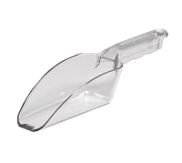 | 1 ea | SCOOP  Cambro Model No. SCP12CW135  Camwear® Scoop, 12 oz., polycarbonate, clear, NSF
Item | Qty | Description | Price
E344  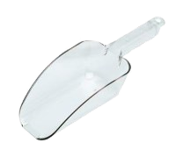 | 1 ea | SCOOP  Cambro Model No. SCP24CW135  Camwear® Scoop, 24 oz., polycarbonate, clear, NSF
E345  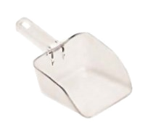 | 1 ea | SCOOP  Rubbermaid Model No. FG288400CLR  Bouncer® Utility Scoop, 32 oz., smooth surface, dishwasher safe, break‐resistant polycarbonate, clear, NSF, S.O.S. (Special Order  Smallwares)
E3451  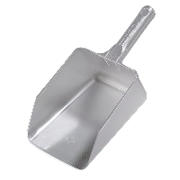 | 1 ea | SCOOP  Carlisle Model No. 436407  Ice Scoop, 64 oz., 14‐2/11" OA length, easy‐grip handle, hanging hole, dishwasher safe, polycarbonate, clear, NSF
E346  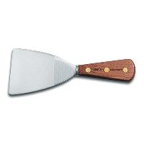 | 1 ea | GRILL SCRAPER  Dexter Russell Model No. 25RC‐3  Traditional™ (16040) Pan Scraper, 3", stiff, round corners, high‐carbon steel, forged, rosewood handle, Made in USA
E349 | 1 ea | SCRAPER  ABC Procurement Model No. PDS‐01  Bowl Scraper, 5‐3/4" x 3‐1/2", flexible plastic, white (inner pack quantity available, contact factory)
E352 | 1 ea | SPATULA  ABC Procurement Model No. SCR‐02  Plate Scraper, 13‐1/2"L, 2‐3/4" wide white vinyl blade, heat resistant to 140°F, white polystyrene handle (inner pack quantity available, contact factory)
E354 | 1 ea | SPATULA  ABC Procurement Model No. SCR‐03  Plate Scraper, 16‐3/4"L, 2‐13/16" wide white vinyl blade, heat resistant to 140°F, white polystyrene handle (inner pack quantity available, contact factory)
E350 | 1 ea | SPATULA  ABC Procurement Model No. SCR‐01  Plate Scraper, 9‐1/2"L, 2" wide white vinyl blade, heat resistant to 140°F, white polystyrene handle (inner pack quantity available, contact factory)

Item | Qty | Description |  | Price
E001B  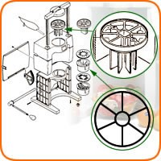 | 1 ea | FRUIT VEGETABLE WEDGER PARTS  Sunkist Model No. S‐34  Apple Corer Set, (6) wedge, (fits S‐32 & S‐33)
E43412  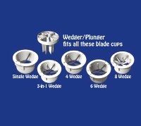 | 1 ea | FRUIT VEGETABLE WEDGER PARTS  Sunkist Model No. S‐4B  Blade Cup, with cover, (6) slice (fits S‐10)
E388A | 1 ea | FRUIT VEGETABLE WEDGER PARTS  Sunkist Model No. S‐5B  Blade Cup, with cover, (4) wedge, (fits S‐9)
E4341  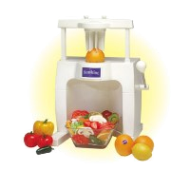 | 1 ea | WEDGER  Sunkist Model No. S‐102  Complete Sectionizer Unit, manual, (6) cut wedges, interchangeable blade cups, dishwasher safe, NSF
 |  | Wedge cups are interchangeable and use the same plunger
E363  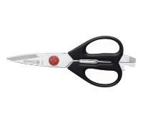 | 1 ea | KITCHEN SHEARS  Mundial Model No. BP666  Take‐A‐Part Kitchen Shears, 8", stainless steel blades, black plastic handles (blister pack)
E450 | 1 ea | SKIMMER  Browne USA Foodservice Model No. 1309  Skimmer, 9" dia., 17‐1/2"L, hooked handle, coarse mesh, spiral wire, nickel‐plated
E451  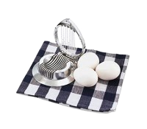 | 1 ea | EGG / MUSHROOM SLICER  Vollrath Model No. 47040  Egg Slicer, cast aluminum, 4‐1/2" diameter, imported
E435  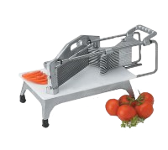 | 1 ea | TOMATO SLICER  Vollrath Model No. 0643N  Redco® Tomato Pro™ Tomato Slicer, 3/16" cut size, straight blades, NSF
Item | Qty | Description |  | Price
E2141  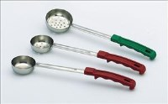 | 1 ea | PORTION CONTROL LADLE  ABC Procurement Model No. PPG‐4‐P  Portion Server, perforated, 4 oz., stainless steel, green 10‐1/2" plastic handle, NSF
E2161 | 1 ea | PORTION CONTROL LADLE  ABC Procurement Model No. PPG‐6‐P  Portion Server, perforated, 6 oz., stainless steel, black 10‐1/2" plastic handle, NSF
E2171 | 1 ea | PORTION CONTROL LADLE  ABC Procurement Model No. PPG‐8‐P  Portion Server, perforated, 8 oz., stainless steel, blue 10‐1/2" plastic handle, NSF
E2181 | 1 ea | PORTION CONTROL LADLE  ABC Procurement Model No. PPG‐2‐S  Portion Server, solid, 2 oz., stainless steel, red 10‐1/2" plastic handle, NSF
E2191 | 1 ea | PORTION CONTROL LADLE  ABC Procurement Model No. PPG‐3‐S  Portion Server, solid, 3 oz., stainless steel, beige 10‐1/2" plastic handle, NSF
E2211 | 1 ea | PORTION CONTROL LADLE  ABC Procurement Model No. PPG‐4‐S  Portion Server, solid, 4 oz., stainless steel, green 10‐1/2" plastic handle, NSF
E2221 | 1 ea | PORTION CONTROL LADLE  ABC Procurement Model No. PPG‐6‐S  Portion Server, solid, 6 oz., stainless steel, black 10‐1/2" plastic handle, NSF
E223 | 1 ea | PORTION CONTROL LADLE  ABC Procurement Model No. PPG‐8‐S  Portion Server, solid, 8 oz., stainless steel, blue 10‐1/2" plastic handle, NSF
E2111 | 1 ea | PORTION CONTROL LADLE  ABC Procurement Model No. PPG‐2‐P  Portion Server, perforated, 2 oz., stainless steel, red 10‐1/2" plastic handle, NSF
E2121 | 1 ea | PORTION CONTROL LADLE  ABC Procurement Model No. PPG‐3‐P  Portion Server, perforated, 3 oz., stainless steel, beige 10‐1/2" plastic handle, NSF

Item | Qty | Description | Price
E242  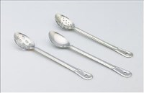 | 1 ea | SOLID SERVING SPOON  ABC Procurement Model No. BSH‐15‐S‐P  Serving Spoons, 15", solid, 1.2mm stainless steel, NSF
E228 | 1 ea | MEASURING SPOON  Browne USA Foodservice Model No. 2316  Measuring Spoon Set, includes: 1/4, 1/2, 1 teaspoon & 1 tablespoon, US standard capacities, stainless steel
E234 | 1 ea | PERFORATED SERVING SPOON  ABC Procurement Model No. BSH‐13‐P‐P  Serving Spoons, 13", perforated, 1.2mm stainless steel, NSF
E032  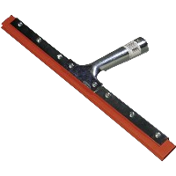 | 1 ea | SQUEEGEE  Carlisle Model No. 4007400  Hand Held Window Squeegee, 14" double‐blade, red rubber, screw‐in metal frame, zinc plated steel handle, standard color
E452  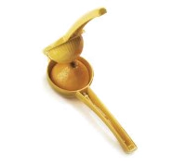 | 1 ea | LEMON LIME SQUEEZER  Focus Foodservice Model No. 8565  Lemon Squeezer, 8‐3/4" long, 3" dia., enameled aluminum, yellow, with hang tag (sold in case packs only)
E179  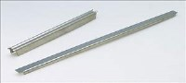 | 1 ea | ADAPTER BAR  ABC Procurement Model No. AB‐12  Adapter Bar, 12"L, flat, mirror finish, stainless steel, NSF
E179A | 1 ea | ADAPTER BAR  ABC Procurement Model No. AB‐20  Adapter Bar, 20"L, flat, mirror finish, stainless steel, NSF
E468  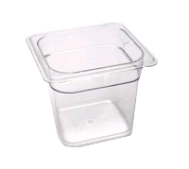 | 1 ea | PLASTIC FOOD PAN  Cambro Model No. 66CW135  Camwear® Food Pan, 2.4 qt. capacity, 6" deep, 1/6 size, polycarbonate, clear, NSF  2 year warranty
E3721  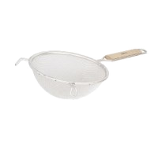 | 1 ea | MESH STRAINER  Browne USA Foodservice Model No. 8199  Strainer, 10‐3/4" bowl, 9"L handle, double medium mesh, wood flatbottom handle, pan hook, reinforced wire rim, full‐bathed tinned  (priced per each, packed 6 per case and 24 per master case)
Item | Qty | Description |  | Price
E374C  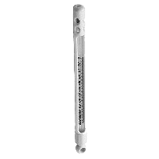 | 1 ea | DISHWASHER THERMOMETER  Taylor Precision Model No. 21462‐1J  Dishwasher Test Thermometer, 0° to 220°F temperature range, open face MINLON® plastic armor case, non‐refillable, mercury filled, maximum registering glass tube, Permark pigment scale, individually packaged
E374 | 1 ea | REFRIG/FREEZER THERMOMETER  ABC Procurement Model No. TH‐15  Refrigerator/Freezer Thermometer, ‐40°F to 80°F (‐40°C to 25°C), tube style, liquid, plastic cover
E3732  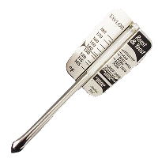 | 1 ea | MEAT THERMOMETER  Taylor Precision Model No. 5937N  Multi‐Purpose Meat Thermometer, tube type, 105° to 185°F  temperature range, armored sabre‐tipped non‐toxic liquid filled tube, dishwasher safe, stainless steel, blister carded, NSF
E373A  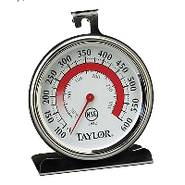 | 1 ea | OVEN THERMOMETER  Taylor Precision Model No. 5932  Oven Thermometer, 3‐1/4" dial with glass lens, 100° to 600°F (50° to  300° C)temperature range, stainless steel casing, hangs or stands, NSF
E373  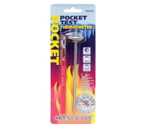 | 1 ea | THERMOMETER, POCKET  Crestware Model No. TRM220C  Pocket Thermometer, 1", 0° to 220°F, concave polycarbonate lens, storage sleeve, pocket clip, stainless steel construction with calibration hex nut, carded, NSF
E375  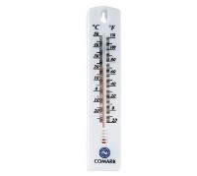 | 1 ea | THERMOMETER, WINDOW WALL  Fluke Electronics (Comark) Model No. WT4  Wall Thermometer, ‐20°F to +120°Fº / ‐28°C to +50°C on display card
E373B  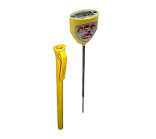 | 1 ea | THERMOMETER, POCKET  Cooper‐Atkins Model No. DFP450W‐0‐8  Test Thermometer, digital display with stem, 4‐3/4" (121mm) shaft length, 3/4" (19mm) tip, ‐40 to 450°F/‐40° to 232°C temperature range, ±2°F/1°C temperature accuracy, waterproof, update button, 1.5v/#392 battery, antimicrobial additive, NSF, CE, WEEE, RoHS (carded) (36 master carton) (Cooper)  Lifetime warranty, includes calibration
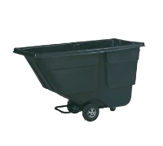  E0991 | 1 ea | TILT TRUCK, MOBILE  Rubbermaid Model No. FG9T1800BLA  Rotational Molded Tilt Truck, standard duty, 600 lb. capacity, 1 cu. yd., 72‐1/4"L x 33‐1/2"W x 43‐3/4"H, seamless one‐piece body with reinforced lip, rust, dent, chip/peel resistant, corrosion resistant powder coated steel frame, easy maneuvering/handling, durable one piece 10" blow‐molded polypropylene inset wheels, 4" center swivel back casters, black

Item | Qty | Description | Price
E376  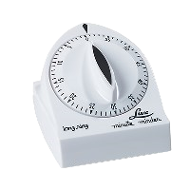 | 1 ea | TIMER, MANUAL  Carlisle Model No. 60300  Timer, 4"L x 3‐1/4"W x 2‐1/4"H, manual turn dial, one‐hour limit in 5 minute increments, long ring, dishwasher safe, ABS‐plastic, white
E378  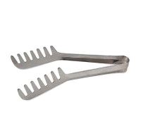 | 1 ea | SPAGHETTI TONGS  Browne USA Foodservice Model No. 5313  Spaghetti Tongs, 7‐1/2"L, blunted tip on each side, 0.6 mm thickness, spring steel
E382  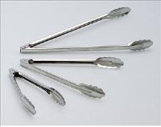 | 1 ea | UTILITY TONGS  ABC Procurement Model No. UTR‐12  Utility Tongs, standard, 12"L, two‐piece, coil spring operated, scalloped edges, 0.6 mm thickness, stainless steel
E380  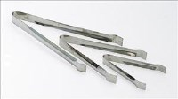 | 1 ea | ICE / POM TONGS  ABC Procurement Model No. PTR‐06  Pom Tong, 6" stainless steel
E381 | 1 ea | UTILITY TONGS  ABC Procurement Model No. UTR‐09  Utility Tongs, standard, 9‐1/2"L, two‐piece, coil spring operated, scalloped edges, 0.6 mm thickness, stainless steel
E381A  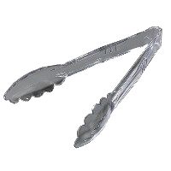 | 1 ea | PLASTIC SERVING / UTILITY TONGS  Carlisle Model No. 410907  Carly® Utility Tong, 9"L, one‐piece, temperature range up to 212° F & dry heat up to 270° F, break resistant, dishwasher safe, polycarbonate, clear, NSF
E407  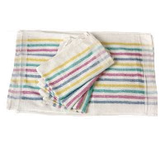 | 1 dz | KITCHEN TOWEL  Chef Revival Model No. 705MSK  Multi‐Stripe Towel, 15" x 26", 100% cotton terry cloth, Chef 24/7®
E465  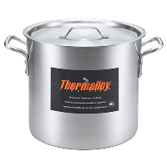 | 1 ea | STOCK POT  Browne USA Foodservice Model No. 5813108  Thermalloy® Stock Pot, 8 qt., 9" x 7‐1/2", without cover, oversized riveted handles, 6 gauge, aluminum, NSF
Item | Qty | Description |  | Price
E465A  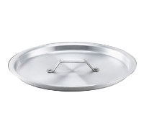 | 1 ea | COVER / LID, COOKWARE  Browne USA Foodservice Model No. 5815008  Thermalloy® Stock Pot Cover, flat, fits 58 13108 & 58 14108, 6 gauge aluminum
E466  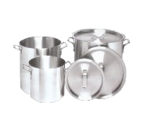 | 1 ea | STOCK POT  Vollrath Model No. 7303  Arkadia™ Stock Pot, 12 quart, 3000 series aluminum
E466A | 1 ea | COVER / LID, COOKWARE  Vollrath Model No. 7389  7389 Arkadia™ Cover, for 7302, 7303, 7304, 3000 series aluminum
E467 | 1 ea | STOCK POT  Vollrath Model No. 7308  Arkadia™ Stock Pot, 32 quart, 3000 series aluminum
E467A  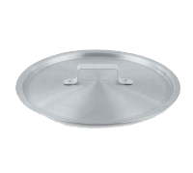 | 1 ea | COVER / LID, COOKWARE  Vollrath Model No. 7351C  7351C Arkadia™ Cover, for 7308 & 7310 stock pots, NSF
E0813  A  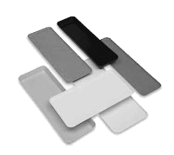 | 1 ea | DISPLAY TRAY, MARKET / BAKERY  Cambro Model No. 926MT110  Market Display Tray, 8‐7/8" x 25‐9/16" x 1", rectangular, dishwasher safe, fiberglass, black, NSF  3 year pro‐rated warranty against manufacturer's defects  Special Order item not carried in stock; NON‐Returnable, (1) full case minimum
E461  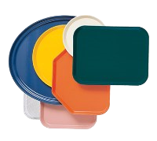 | 1 ea | CAFETERIA TRAY  Cambro Model No. 1422TR110  Camtray®, trapezoid, 14" x 22", high‐impact fiberglass, color permanently molded into tray, dishwasher safe, black, NSF  5 year warranty  Special Order item not carried in stock; NON‐Returnable, (1) full case minimum  SPECIFY COLOR WHEN ORDERING

Item | Qty | Description | Price
E0812  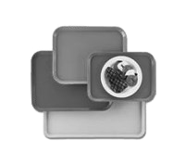 | 1 ea | CAFETERIA TRAY  Cambro Model No. 1826CL110  Camlite® Tray, reinforced edges, 17‐7/8" x 25‐3/4", rectangular, dishwasher safe, fiberglass, stacking lugs, Dri‐Stak, black, NSF
3 year pro‐rated warranty against manufacturer's defects
SPECIFY COLOR WHEN ORDERING
E0813 | 1 ea | DISPLAY TRAY, MARKET / BAKERY  Cambro Model No. 8262MT110  Display Market Pan, 8‐3/8" x 25‐1/2" x 2", rectangular, dishwasher safe, fiberglass, black, NSF
 |  | 3 year pro‐rated warranty against manufacturer's defects
 |  | Special Order item not carried in stock; NON‐Returnable, (1) full case minimum
E383  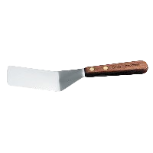 | 1 ea | SOLID TURNER  Dexter Russell Model No. S242PCP  Traditional™ (19670) Pancake Turner, 4" x 2", solid, stainless steel, offset blade, rosewood handle, Perfect Cutlery Packaging, Made in USA
E384  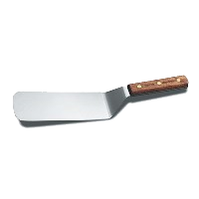 | 1 ea | SOLID TURNER  Dexter Russell Model No. S8698PCP  Traditional™ (19690) Grill Turner, 8" x 3", stiff, offset, stainless steel blade, rosewood handle, Perfect Cutlery Packaging, Made in USA
E386  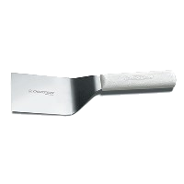 | 1 ea | SOLID TURNER  Dexter Russell Model No. S286‐6PCP  Sani‐Safe® (19683) Hamburger Turner, 6" x 3", square end, solid, stiff, offset, stainless steel blade, textured, polypropylene white handle, Perfect Cutlery Packaging, NSF Certified
E388  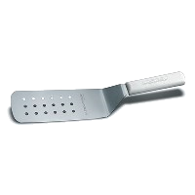 | 1 ea | PERFORATED TURNER  Dexter Russell Model No. PS286‐8PCP  Sani‐Safe® (19703) Perforated Turner, 8" x 3", stainless steel, offset blade, textured, polypropylene white handle, Perfect Cutlery  Packaging, NSF Certified, Made in USA

LINE ITEM GRAND TOTAL DOLLAR AMOUNT:_$_________________

Addendums numbered _______thru _______ were received prior to my signing this proposal document.

Item | Qty | Description | Price
E389  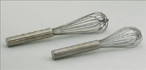 | 1 ea | FRENCH WHIP  ABC Procurement Model No. WF‐12  French Whip, 12"L, stainless steel
E390 | 1 ea | FRENCH WHIP  ABC Procurement Model No. WF‐24  French Whip, 24"L, stainless steel
E391 | 1 ea | PIANO WHIP  ABC Procurement Model No. WP‐12  Piano Whip, 12"L, stainless steel
E033  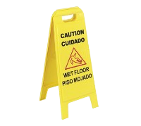 | 1 ea | FLOOR SIGN  Carlisle Model No. 3690000  Flo‐Pac® Safety Floor Sign, "Wet Floor", 11"W x 25"H, lockable, two sided, contoured feet, multi‐lingual (English/Spanish), polypropylene, yellow

COMPANY: _________________________________________________
ADDRESS: __________________________________________________
CITY/STATE: _________________________________________ ZIP:________________
SIGNATURE: ____________________ _________________________ DATE: ___________________
TITLE: ______________________________________________

By signing and submitting a proposal, your firm acknowledges and agrees that it has
read and understands the bid documents.

- BID SUBMISSION DOCUMENTATION CHECKLIST

Bidder must return the following pages with your bid. If bidder fails to provide the following, your bid shall be incomplete and cause for rejection. It is the responsibility of the bidder to ensure that it has received all addenda and to include signed copies with their bid.

ITEM: INCLUDED: (X)
- Statement of Assurances and Compliances (pg. 8) ____
- Statement of Certification (pg. 9) ____
- Addenda, if any ____
- Small Kitchen Equipment Items Worksheet (pg. 11-38) ____
- Three (3) written references of adequate financial capacity ____
- Three (3) written reference letters from other school districts ____

ADDITIONAL ITEMS: INCLUDED: (X)
- W9 (needed if bid is awarded) ____
- Any additional information that you would like to add
pertinent to your firm and bid ____

Person to contact regarding this bid: _______________________________________________

Title:___________________________ Phone:_____________________Fax:____________________

Name of person authorized to bind the Firm:_____________________________________________

Signature: ________________________________________________Date:____________________

By signing and submitting a bid, your firm acknowledges and agrees that it has
read and understands the bid documents.

