Amendment One To:
Invitation for Bids
RFx No. 3160001794
Smart No. 1450-17-R-IFBD-00008
MARINE PATROL VESSEL

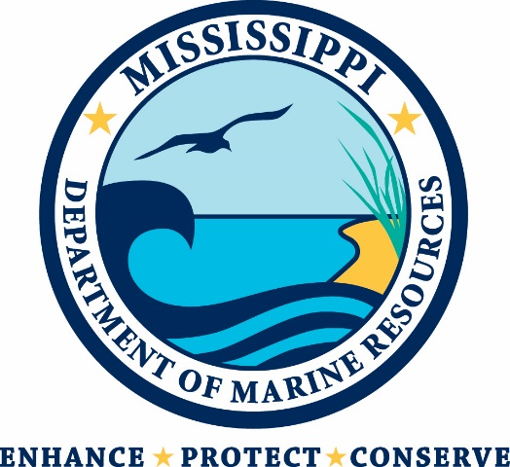

Mississippi Department of Marine Resources

1141 Bayview Avenue

Biloxi, Mississippi 39530
Contact: Kacey Williams – Procurement@dmr.ms.gov

THIS IS AMENDMENT ONE TO THE INVITATION FOR BIDS. YOU MUST ACKNOWLEDGE THIS AND ALL FUTURE AMENDMENTS ON THE BID FORM (ATTACHMENT D) OR, IF YOUR BID HAS ALREADY BEEN SUBMITTED, BY LETTER. YOUR ACKNOWLEDGMENT OF ALL AMENDMENTS MUST BE RECEIVED BY THE MDMR BY THE DEADLINE FOR RECEIPT OF YOUR BID.

The purpose of this amendment is to changes to the schedule. The revised schedule is below:

IFB Issue Date | October 27, 2017
Newspaper Publication Dates | October 27, 2017 & November 3, 2017
Deadline for Questions to MDMR | November 8, 2017 at 10:00 a.m. CST
Posting of Written Answers to Questions | November 9, 2017 at 4:00 p.m. CST
Bid Submission Deadline | November 17, 2017 at 2:00 p.m. CST

Section 4 - MDMR Contact and Questions/Requests for Clarification
All questions and requests for clarification must be submitted by email to:
Kacey Williams, CFO at procurement@dmr.ms.gov

All questions/requests for clarification must be received no later than November 8, 2017 at 10:00 a.m. CST.
All questions/requests for clarification and the answers thereto will be published on the MDMR website (http://dmr.ms.gov) and the MAGIC Portal http://www.mmrs.state.ms.us/vendors/index.shtml in a manner that all bidders will be able to view by November 9, 2017 at 4:00 p.m. CST.
The MDMR will not be bound by any verbal or written information that is not specified within this IFB unless formally noticed and issued by the contact person.

