Harrison County School District

HENRY A. ARLEDGE
Superintendent of Education
11072 Highway 49
Gulfport, Mississippi 39503 (228) 539-6500
(228) 539-6507
E. MITCHELL KING
Assistant Superintendent

To: From: Date:
Sun Herald Legal Ads Sherrel Crawford September 3, 2014

Sealed bids will be received by the Harrison County Board of Education until 10:00 a.m., Wednesday, September 24, 2014 for the following:
1. Copier Paper

Specifications and bid proposal forms are on file in the Office of the County Superintendent of Education, 11072 Highway 49, Gulfport, Mississippi (phone number 228-539-6500).
Bids will be opened at 10:00 a.m. on Wednesday, September 24, 2014 in the Office of the

County Superintendent of Education.

The Board reserves the right to reject any or all bids and to waive informalities. Witness my signature this the 3rd day of September 2014.

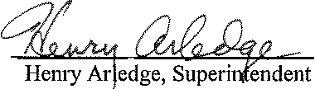

To appear in paper on: September 5, 2014
September 12, 2014

