Notice of Intent to Certify Sole Source

To: Interested Parties

From: Stacy Baldwin
Agency Procurement Officer

Date: June 5, 2017

Re: Sole Source Certification Number SS5099 for Verifit 2 System and Accessories

Contact Email Address: solesource@umc.edu

Sole Source Certification Award Details

Regarding UMMC Sole Source Certification Number SS5099 for Verifit 2 System and Accessories, please be advised that UMMC intends to award the purchase of the Verifit 2 System and Accessories to Audioscan as the sole source provider of the Verifit 2 System and Accessories .

UMMC issues this notice in accordance with Mississippi state law, policy, and procedures for sole source procurements.

Sole Source Criteria

- Where the compatibility of equipment, accessories, or replacement parts is the paramount consideration (and manufacturer is the sole supplier).
- Where a sole supplier’s item is needed for trial use or testing.
- Where a sole supplier’s item is to be required when no other item will service the needs of UMMC.

Schedule

Task | Date
First Advertisement Date | June 5, 2017
Second Advertisement Date | June 12, 2017
Response Deadline from Objectors | June 19, 2017, at 3:00 p.m. Central Time
Notice of Award/No Award Posted | Not before July 19, 2017

Project Details

- Describe the commodity that the agency is seeking to procure:
The University of Mississippi Medical Center (UMMC) seeks to purchase the Verifit 2 system and associated accessories.

The Verifit 2 system is a fully binaural platform that provides the fitting tools required to create and sustain satisfaction regardless of hearing device type or technology. The Verifit 2 is designed to verify binaurally both on the ear and in the test box. This provides an accurate real time simulation of both devices at one time and allows for you to get more repeatable results faster.

- Explain why the commodity is the only one (1) that can meet the needs of the agency:
The Verifit 2 system will be utilized to support research for the ARIC Study. UMMC is only one of four ARIC Study sites that will be using this equipment. It is required that all ARIC sites utilize the exact same equipment so that the data will not vary based on different equipment being used at one site versus another.

- Explain why the source is the only person or entity that can provide the required commodity:
Audioscan is the sole distributor of the Verifit 2 system and accessories. See supporting letter from Audioscan, Attachment A.

- Explain why the amount to be expended for the commodity is reasonable:
The estimated amount to be expended is for the purchase of the Verifit 2 System and Accessories is $30,000. This amount is within the expected price range for these products.

- Describe the efforts that the agency went through to obtain the best possible price for the commodity:
Through market intelligence, UMMC was able to negotiate best pricing for these products. All applicable discounts were explored and applied.

Submission Instructions and Format of Response from Objecting Parties

Interested parties who have reason to believe that the Verifit 2 System and Accessories (hereafter, “Products”) should not be certified as a sole source should provide information in the Vendor Form for the State to use in determining whether or not to proceed with awarding the sole source to Audioscan. The Vendor Form may be found at http://www.dfa.state.ms.us/Purchasing/documents/ObjectiontoSoleSourceDetermination.pdf.

Objections must include the certification in Attachment B.

Comments will be accepted at any time prior to Monday, June 19, 2017, at 3:00 p.m. (Central Time) to solesource@umc.edu. Responses may be delivered via email to solesource@umc.edu. UMMC WILL NOT BE RESPONSIBLE FOR DELAYS IN THE DELIVERY OF RESPONSES. It is solely the responsibility of the Interested Parties that responses reach UMMC on time. Responses received after the deadline and responses that lack all required information will be rejected. UMMC reserves the right to inspect Interested Party’s commodity for comparison purposes.

If you have any questions concerning the information above or if we can be of further assistance, please contact solesource@umc.edu.

Attachment A: Vendor Correspondence
Attachment B: Objection Certification

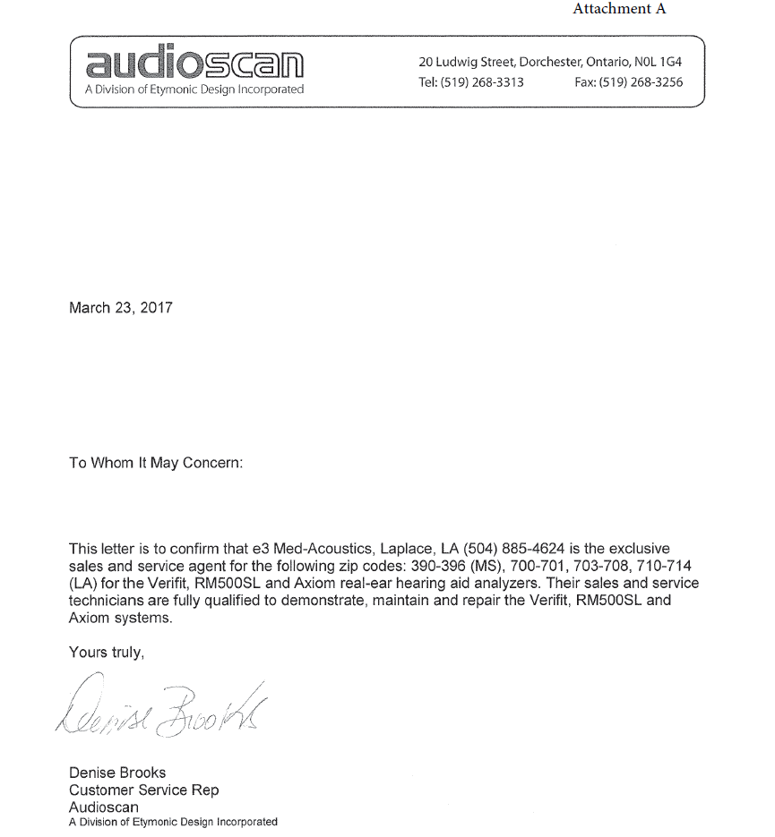
Attachment B

SUBMITTED IN RESPONSE TO
Sole Source Certification No. SS5099
Accepted until June 19, 2017, at 3:00 p.m.

I certify that the information contained in this objection is true and accurate to the best of my knowledge. I understand that UMMC will investigate all statements made in this objection and that any false or misleading information provided may result in adverse action.

__________________________________
Objector Name
Objector’s title

__________________________________
Date

