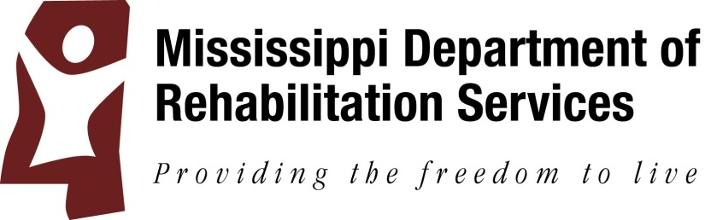

Request for Information

The Mississippi Department of Rehabilitation Services anticipates purchasing the items listed below as a sole source purchase.
Accent 800 and Accent 1000 Speech Generating Devices, and accessories. They offer a choice of vocabulary options to meet the numerous needs of nonverbal individuals.
Objections in response to the above mentioned sole source certification requests are due on Monday September 18, 2017 at 10:00am and should be sent to Brandi Kennedy at the email address listed below. To view the sole source certification request and objection procedure, interested parties should visit the MS Procurement Portal website at https://www.ms.gov/dfa/contract_bid_search.

For questions, please contact Brandi Kennedy, 601.853.5304, bkennedy@mdrs.ms.gov.

The MAGIC RFX# is 3150001095 .

August 28 & September 5

