Notice of Intent to Certify Sole Source

To: Interested Parties

From: Stacy Baldwin
Agency Procurement Officer

Date: June 5, 2017

Re: Sole Source Certification Number SS5098 for Bio-Rad ddSeq Single Cell Isolation System and associated accessories

Contact Email Address: solesource@umc.edu

Sole Source Certification Award Details

Regarding UMMC Sole Source Certification Number SS5098 for Bio-Rad ddSeq Single Cell
Isolation System and associated accessories, please be advised that UMMC intends to award
the purchase of the Bio-Rad ddSeq Single Cell Isolation System and associated accessories
to Bio-Rad Laboratories as the sole source provider of the Bio-Rad ddSeq Single Cell
Isolation System and associated accessories.

UMMC issues this notice in accordance with Mississippi state law, policy, and procedures for sole source procurements.

Sole Source Criteria

- Where the compatibility of equipment, accessories, or replacement parts is the paramount consideration (and manufacturer is the sole supplier).
- Where a sole supplier’s item is needed for trial use or testing.
- Where a sole supplier’s item is to be required when no other item will service the needs of UMMC.

Schedule

Task | Date
First Advertisement Date | June 5, 2017
Second Advertisement Date | June 12, 2017
Response Deadline from Objectors | June 19, 2017, at 3:00 p.m. Central Time
Notice of Award/No Award Posted | Not before July 19, 2017

Project Details

- Describe the commodity that the agency is seeking to procure:
The UMMC Molecular and Genomics Core Facility (MGCF) seeks to purchase a Bio-Rad ddSeq single cell isolation system and associated accessories. This expenditure will be made using extramural funds provided through the Center of Psychiatric Neuroscience (CPN) COBRE grant (and approved through the NIH).

The ddSeq instrument utilizes Bio-Rad’s proprietary droplet technology to capture individual cells within a small droplet. Each individual cell, in combination with specialized Illumina Library Prep, and integration with Illumina MiSeq or NextSeq500 next generation sequencers, will generate single cell transcriptome profiles (on 4 groups ~300-400 cells or 1 group of ~1500 cells). This technology allows for an evaluation of individual cell transcriptomes, thus providing a high-resolution view of cell-to-cell variation.

The MGCF department is in need of a single cell isolation system that allows for the direct sequencing of single cells for gene expression differences in populations of cells. Most importantly, MGCF requires a system that integrates with its current sequencing instrumentation and analysis software. The ddSeq instrument will provide the required capabilities as well as integration with our current Illumina instrumentation.

- Explain why the commodity is the only one (1) that can meet the needs of the agency:
UMMC currently owns Illumina. The Bio-Rad ddSeq instrument is the only system that offers seamless integration from cell culture preparation to the analysis of the data using Illumina instrumentation and data analysis pipelines.

- Explain why the source is the only person or entity that can provide the required commodity:
Bio-Rad is the sole manufacturer and distributor of the ddSeq single cell isolator system and associated accessories. See supporting letter from Bio-Rad Laboratories, Attachment A.

- Explain why the amount to be expended for the commodity is reasonable:
The estimated amount to be expended is for the purchase of the Bio-Rad ddSeq Single Cell Isolation System and associated accessories is $80,000. This amount is within the expected price range for these products.

- Describe the efforts that the agency went through to obtain the best possible price for the commodity:
Through market intelligence, UMMC was able to negotiate best pricing for these products. All applicable discounts were explored and applied.

Submission Instructions and Format of Response from Objecting Parties

Interested parties who have reason to believe that the Bio-Rad ddSeq Single Cell Isolation
System and associated accessories (hereafter, “Products”) should not be certified as a sole
source should provide information in the Vendor Form for the State to use in determining
whether or not to proceed with awarding the sole source to Bio-Rad Laboratories. The Vendor
Form may be found at
http://www.dfa.state.ms.us/Purchasing/documents/ObjectiontoSoleSourceDetermination.pdf.

Objections must include the certification in Attachment B.

Comments will be accepted at any time prior to Monday, June 19, 2017, at 3:00 p.m. (Central Time) to solesource@umc.edu. Responses may be delivered via email to solesource@umc.edu. UMMC WILL NOT BE RESPONSIBLE FOR DELAYS IN THE DELIVERY OF RESPONSES. It is solely the responsibility of the Interested Parties that responses reach UMMC on time. Responses received after the deadline and responses that lack all required information will be rejected. UMMC reserves the right to inspect Interested Party’s commodity for comparison purposes.

If you have any questions concerning the information above or if we can be of further assistance, please contact solesource@umc.edu.

Attachment A: Vendor Correspondence
Attachment B: Objection Certification

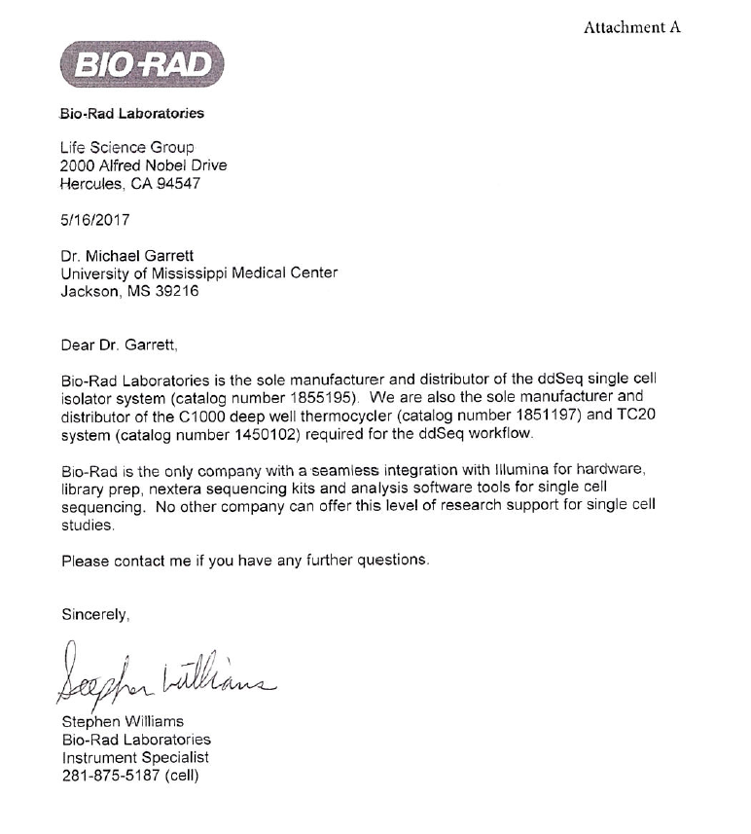
Attachment B

SUBMITTED IN RESPONSE TO
Sole Source Certification No. SS5098
Accepted until June 19, 2017, at 3:00 p.m.

I certify that the information contained in this objection is true and accurate to the best of my knowledge. I understand that UMMC will investigate all statements made in this objection and that any false or misleading information provided may result in adverse action.

__________________________________
Objector Name
Objector’s title

__________________________________
Date

